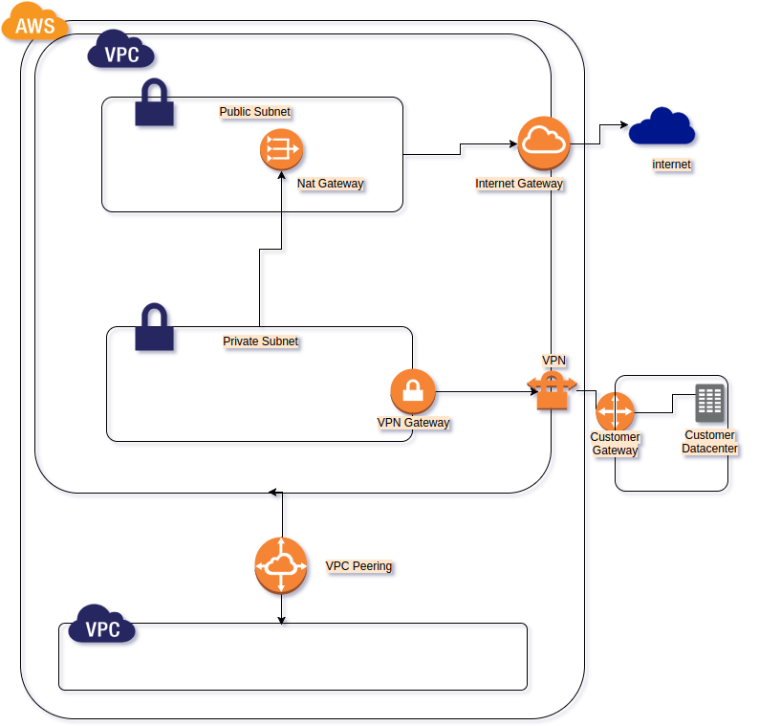   
[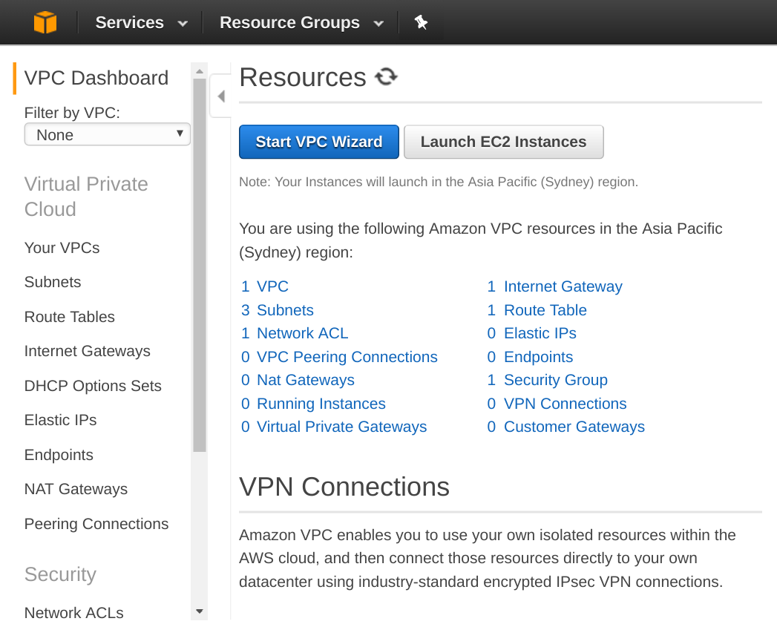](http://www.studytrails.com/wp-content/uploads/2016/11/Selection_239.png) 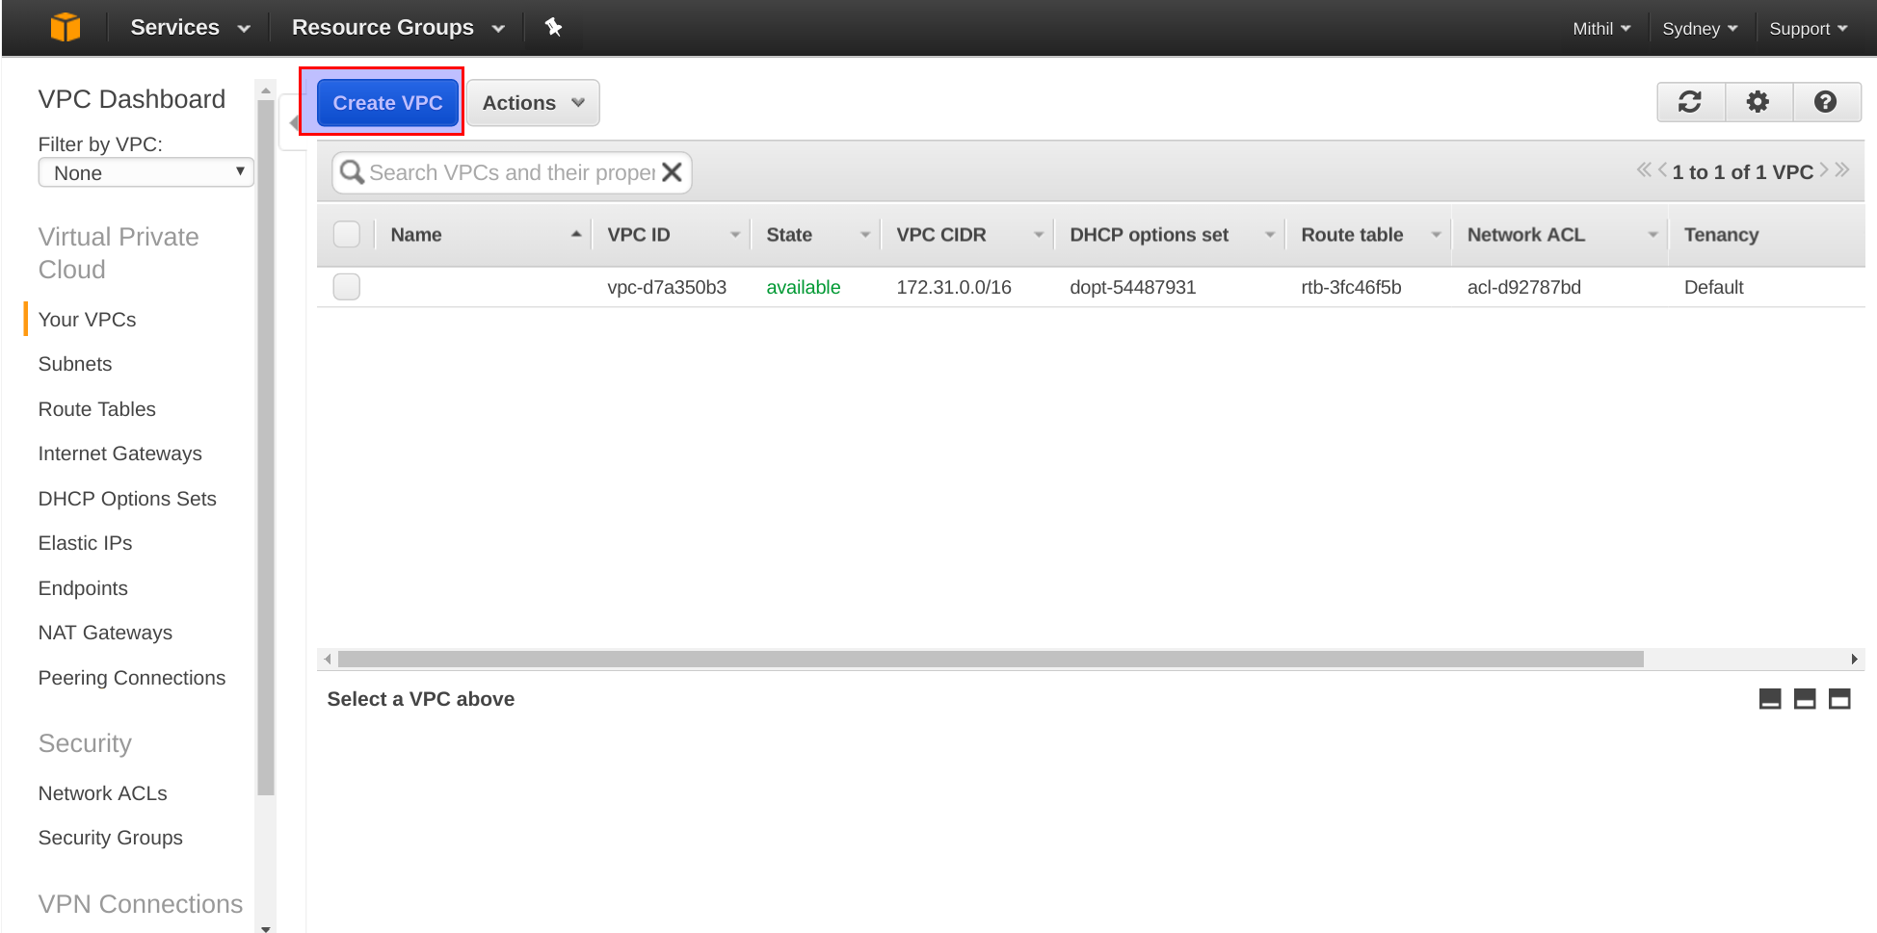  
  
  
[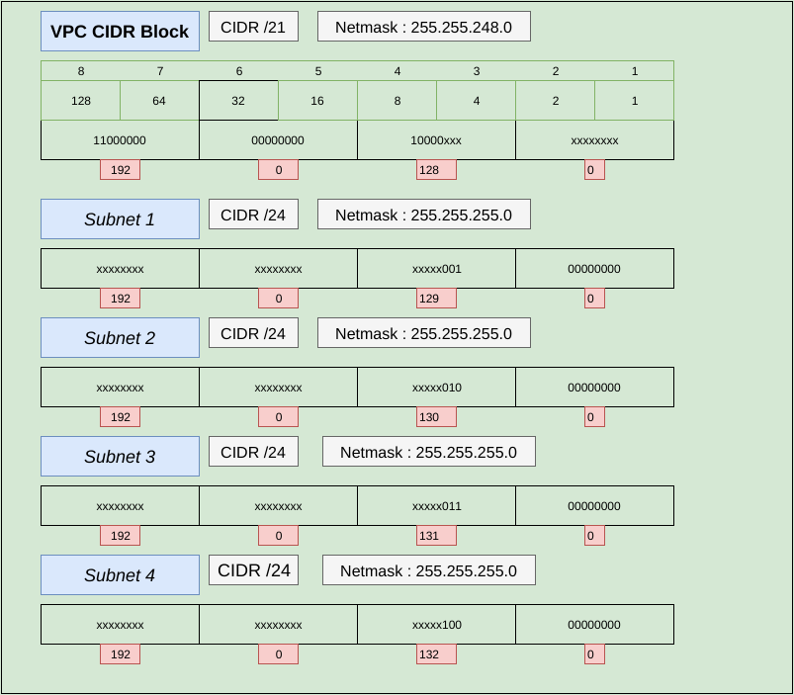](http://www.studytrails.com/wp-content/uploads/2016/11/Subnets.png)

*CIDR block for the AWS VPC*

[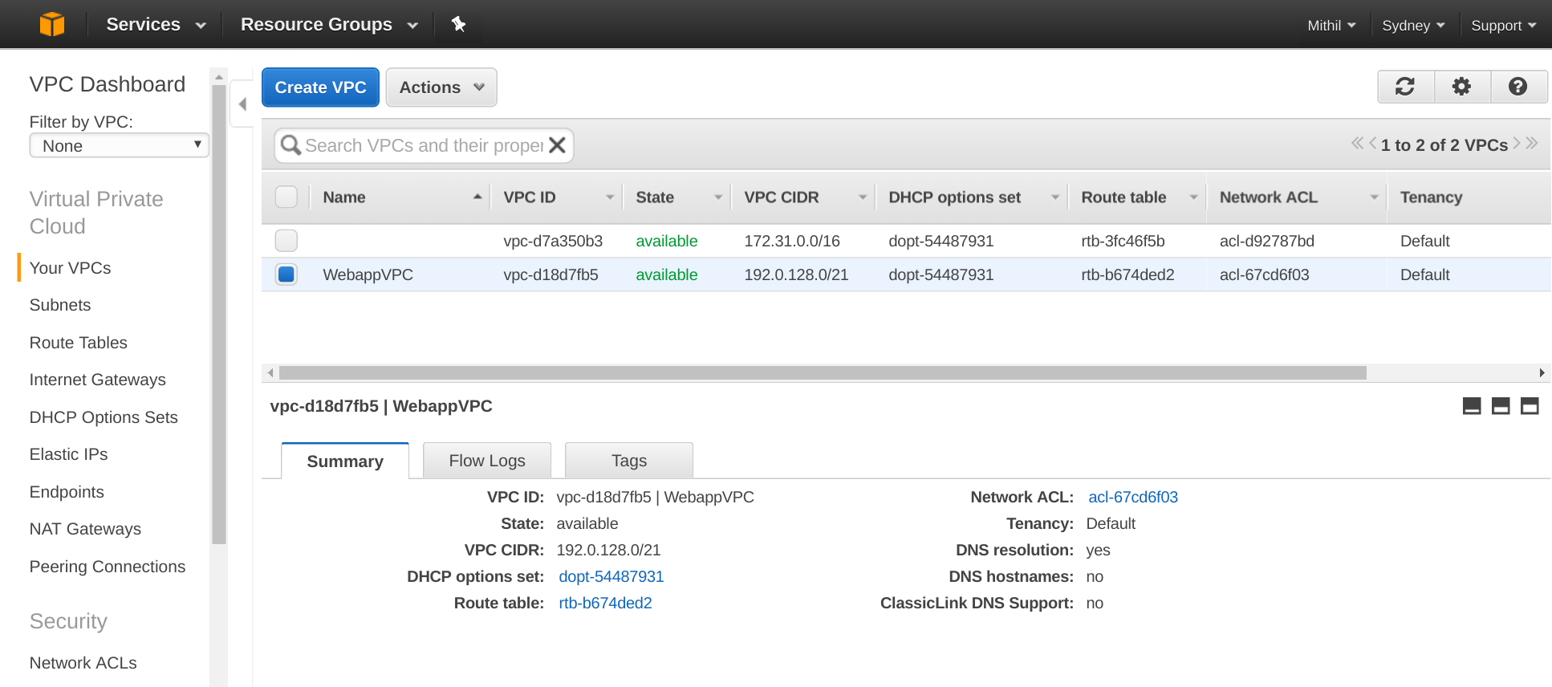](http://www.studytrails.com/wp-content/uploads/2016/11/Selection_242.png)  
  
[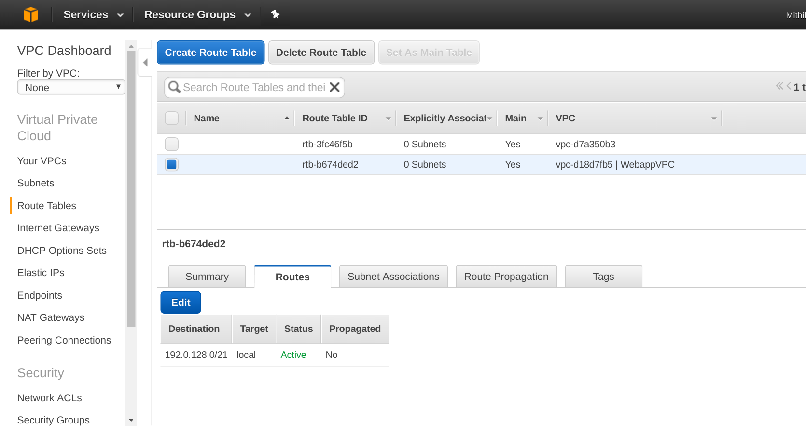](http://www.studytrails.com/wp-content/uploads/2016/11/Selection_243.png)

What is network ACL

**Creating an AWS VPC Subnet Group**

[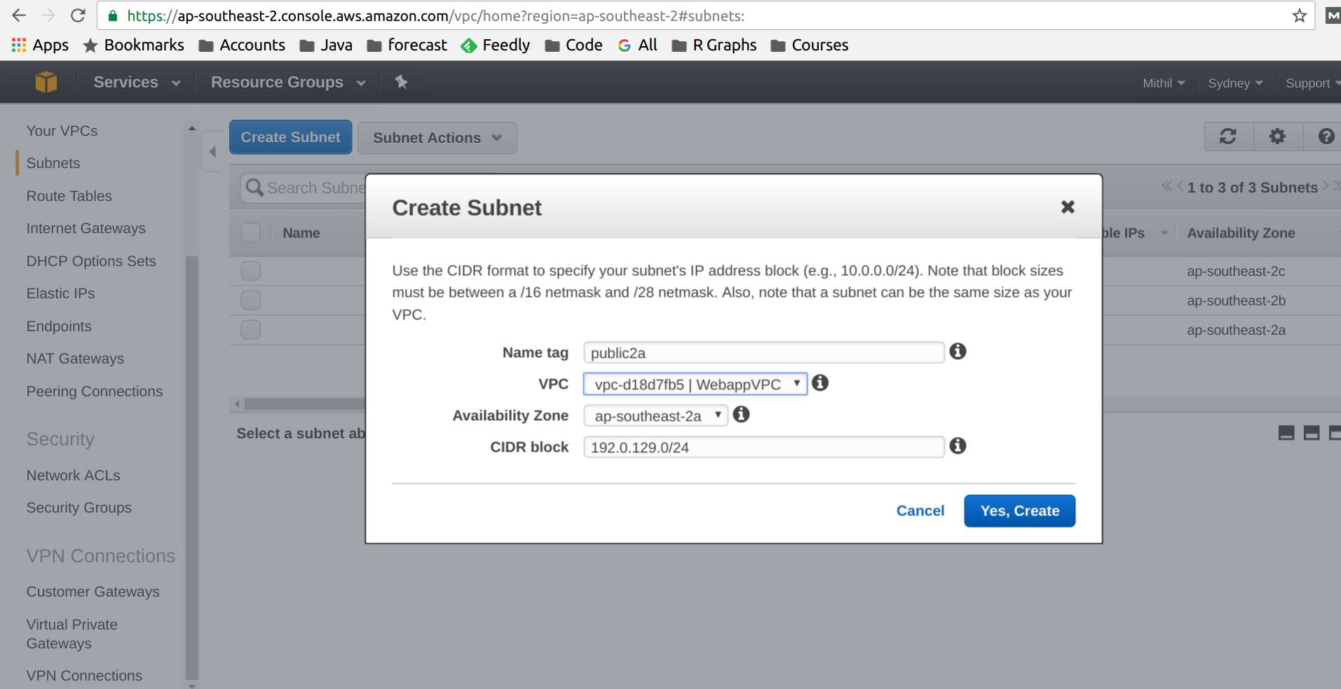](http://www.studytrails.com/wp-content/uploads/2016/11/Selection_245.png)  
  
[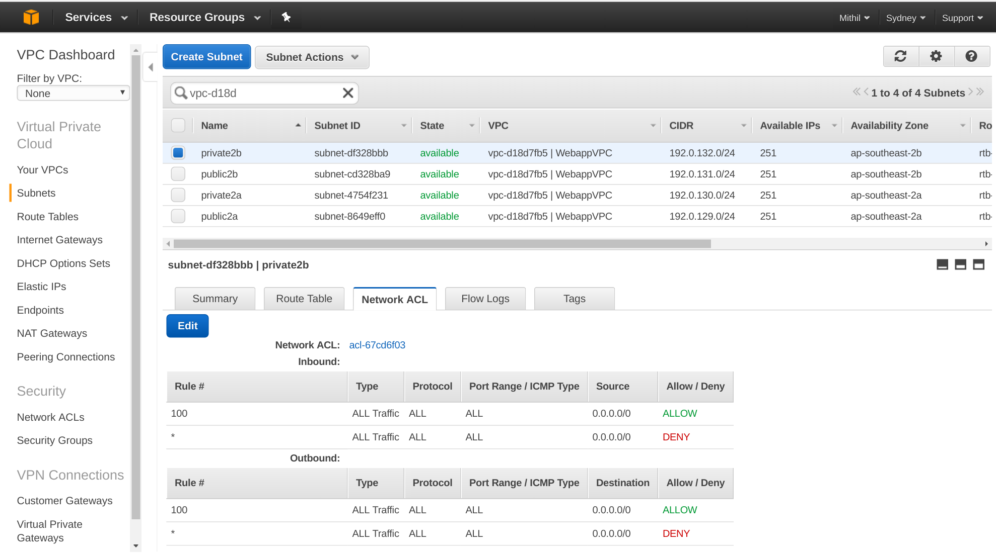](http://www.studytrails.com/wp-content/uploads/2016/11/Selection_246.png)

**Creating an AWS Internet Gateway**

[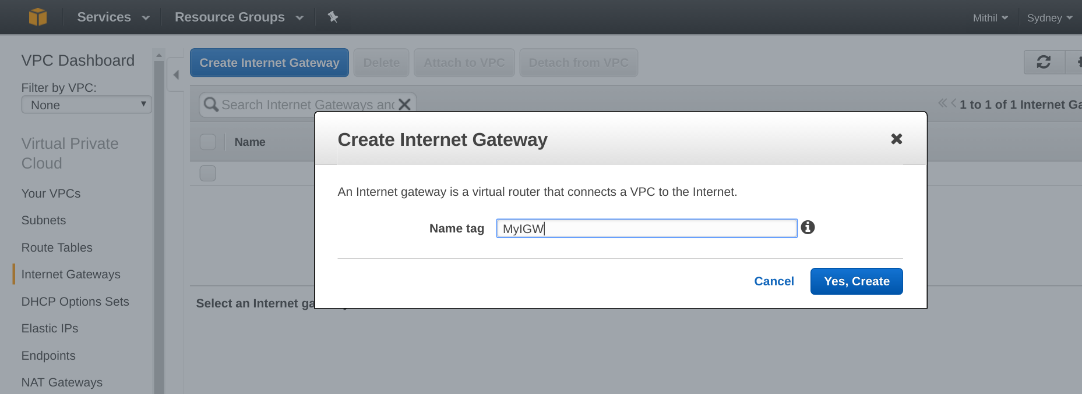](http://www.studytrails.com/wp-content/uploads/2016/11/Selection_247.png)

*Attaching an internet gateway to a VPC*

[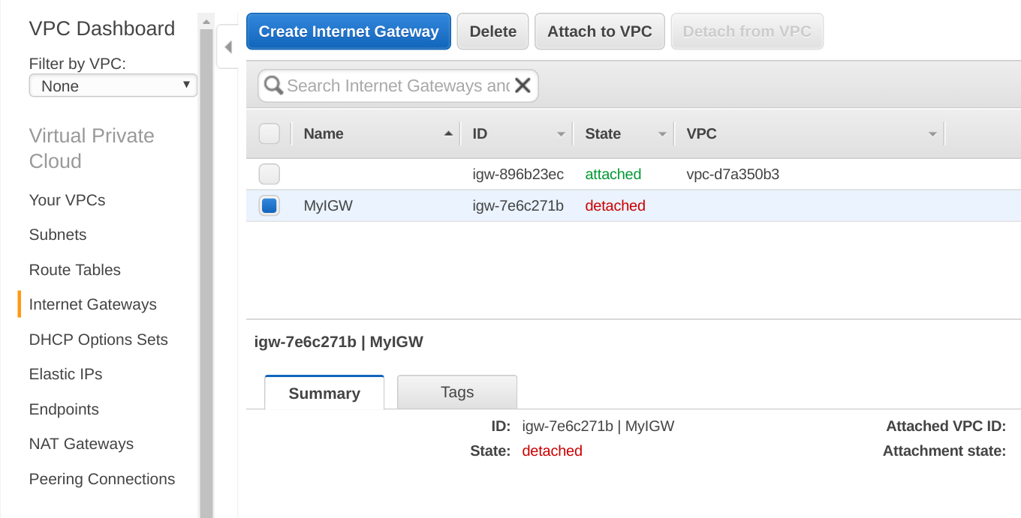](http://www.studytrails.com/wp-content/uploads/2016/11/Selection_251.png)  
  
[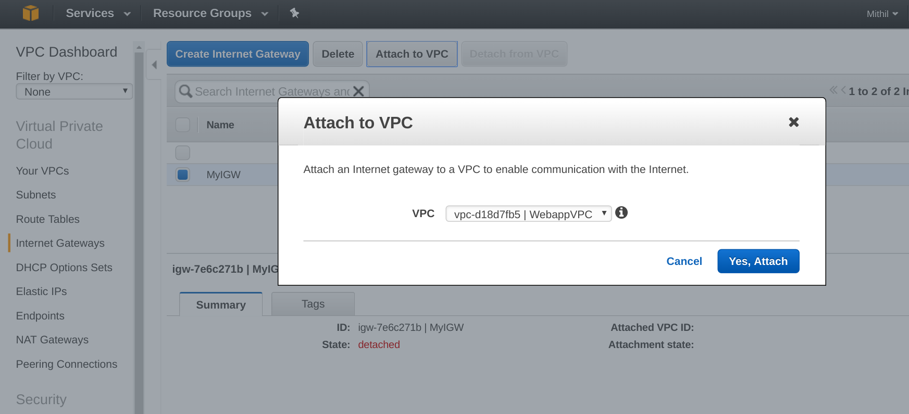](http://www.studytrails.com/wp-content/uploads/2016/11/Selection_252.png)

*Adding route to a VPC*

[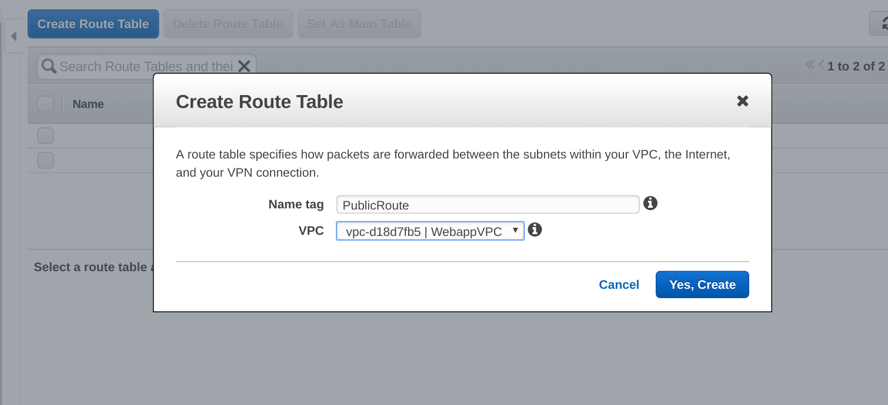](http://www.studytrails.com/wp-content/uploads/2016/11/Selection_254.png)  
  
[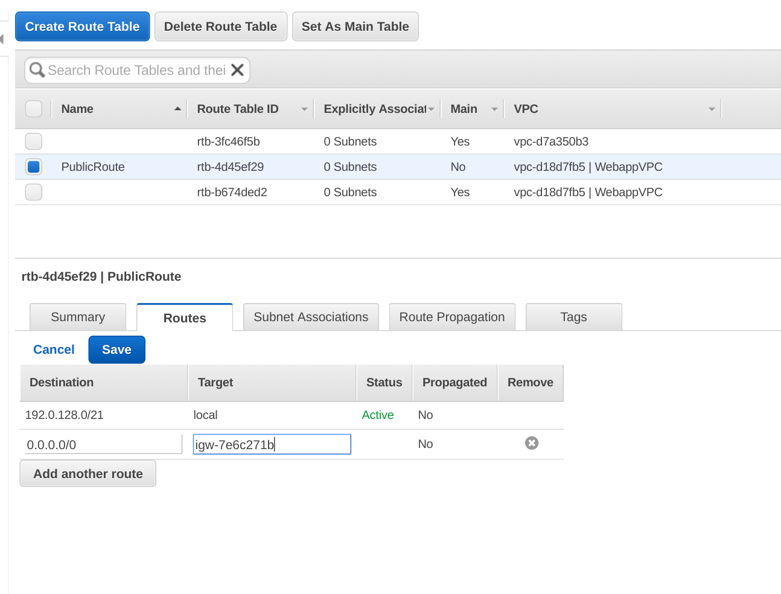](http://www.studytrails.com/wp-content/uploads/2016/11/Selection_255.png)  
  
[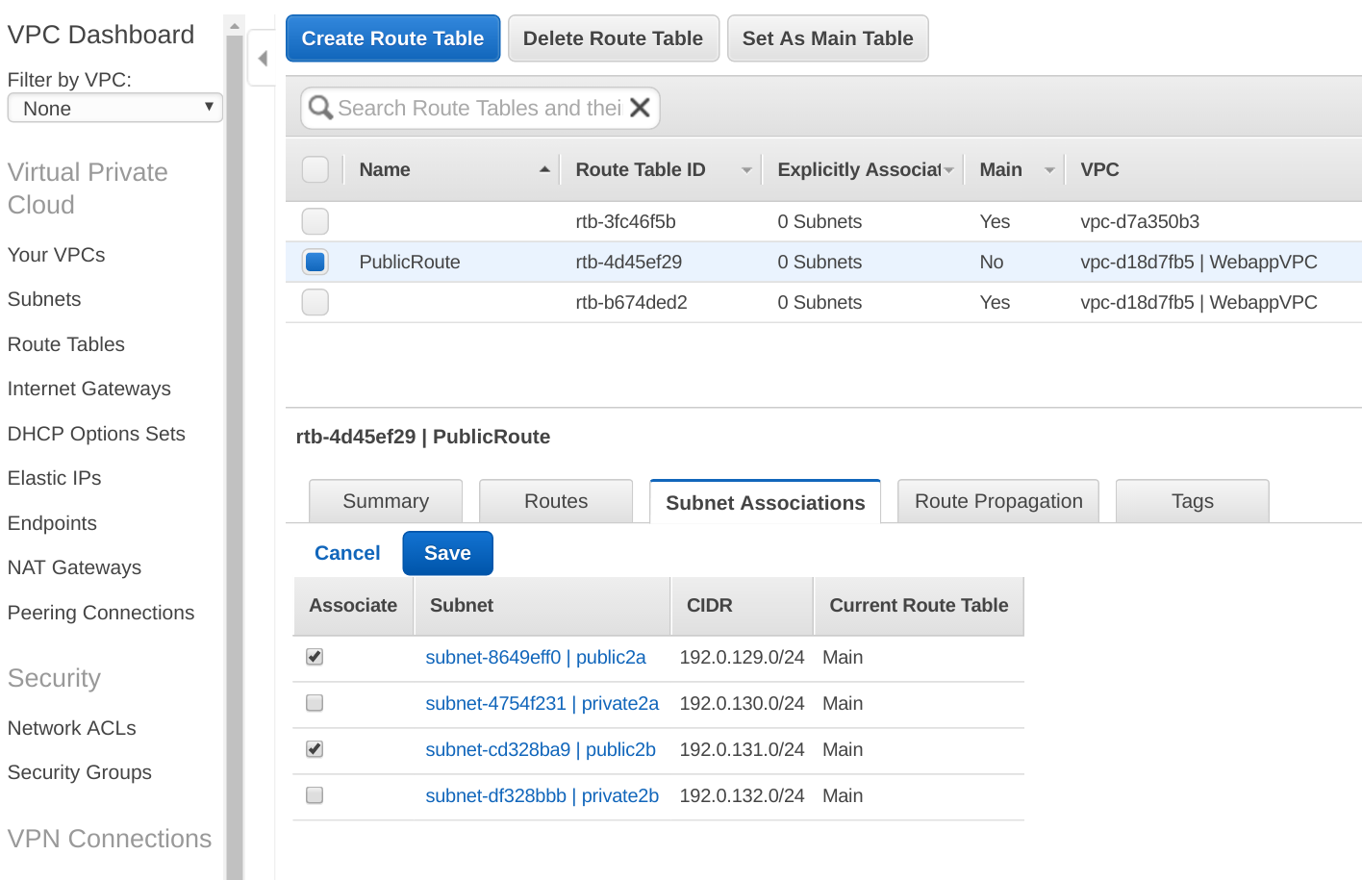](http://www.studytrails.com/wp-content/uploads/2016/11/Selection_256.png)

AWS VPC Tutorial Part III Elastic IP and NAT

[first](http://www.studytrails.com/amazon-aws/aws-vpc-tutorial/)

**Why a NAT Gateway?**

[](http://www.studytrails.com/wp-content/uploads/2016/11/VPCTutorial.png)

**What are Elastic IP addresses**

*Steps to create AWS Elastic IP Address*

[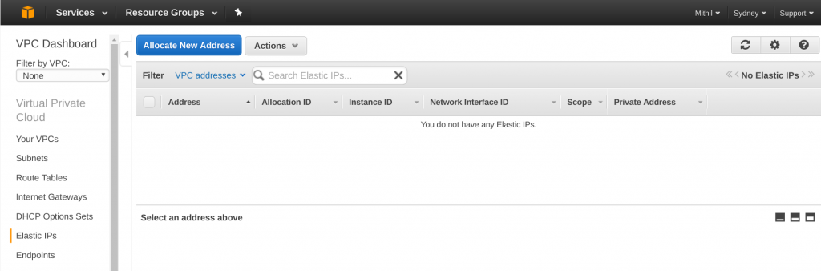](http://www.studytrails.com/wp-content/uploads/2016/11/Selection_257.png)  
  
[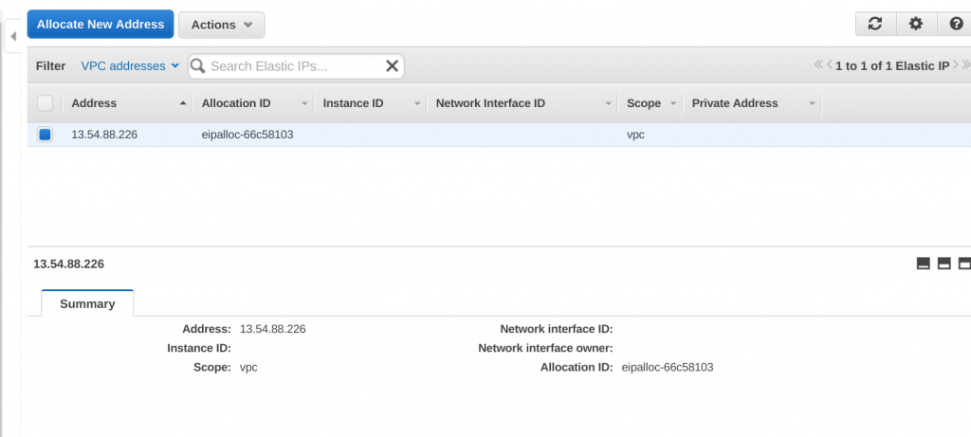](http://www.studytrails.com/wp-content/uploads/2016/11/Selection_258.png)  
  
[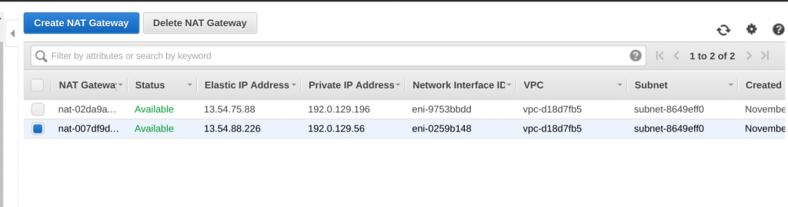](http://www.studytrails.com/wp-content/uploads/2016/11/Selection_263.png)

*Steps to create the NAT gateway*

*Create a Route Table for NAT*

[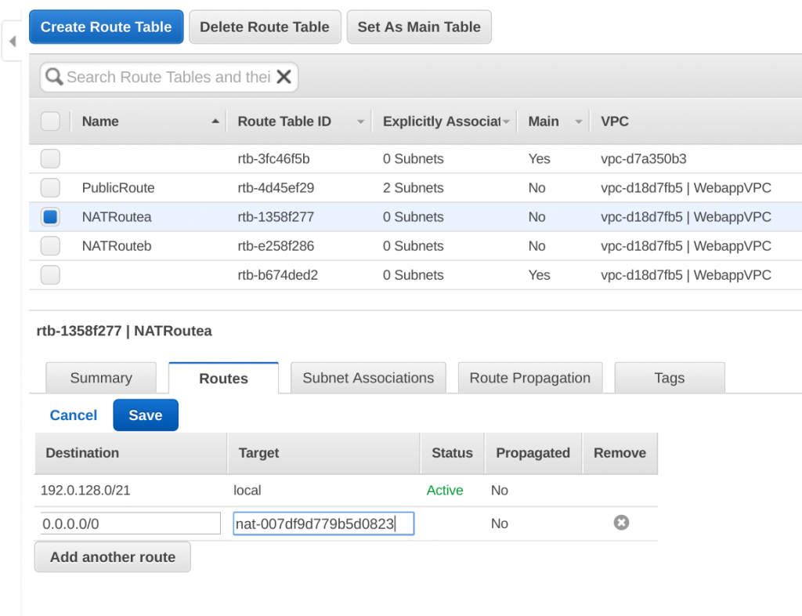](http://www.studytrails.com/wp-content/uploads/2016/11/Selection_264.png)  
  
[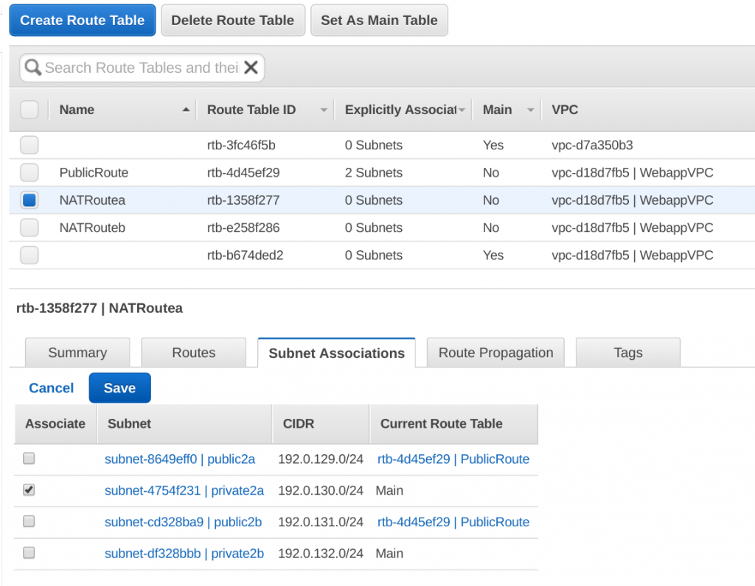](http://www.studytrails.com/wp-content/uploads/2016/11/Selection_265.png)

**Recap of the AWS VPC Tutorial**

A small typo or a minor configuration error here can lead to serious implications including the redesign of our VPC down the road...

I'm recommending doing something like this instead that is…. visualize the entire architecture with all of its components including:

* subnets, custom route tables and associated rules
* all our security groups and associated inbound and outbound traffic rules
* all our CIDR block schemes and
* elastic IPs And
* as well as workflow and communication between various components.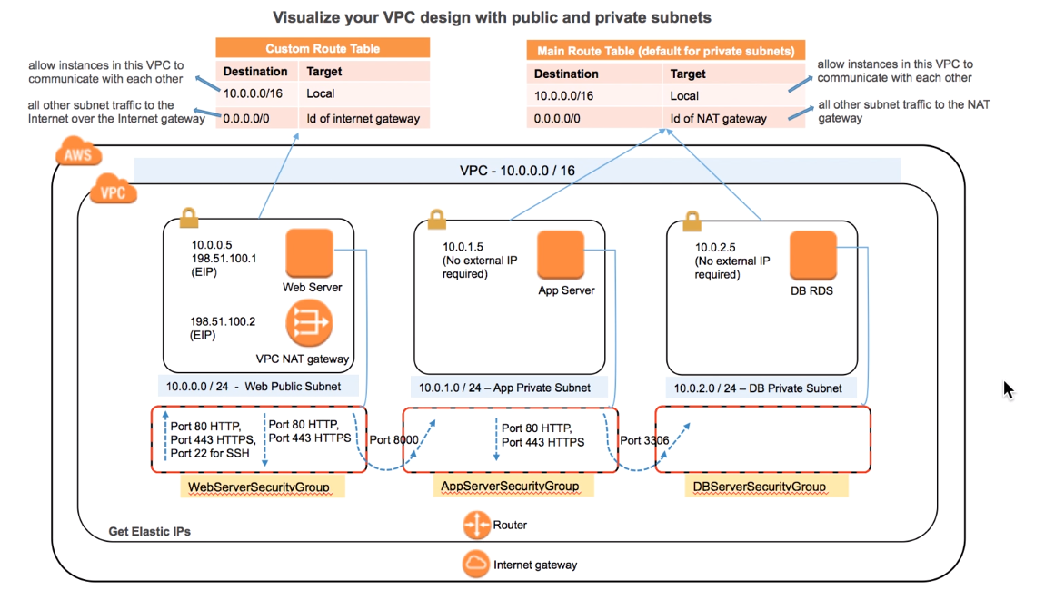

1. I'm visualizing having a VPC with this default CIDR block scheme with in Amazon Cloud.

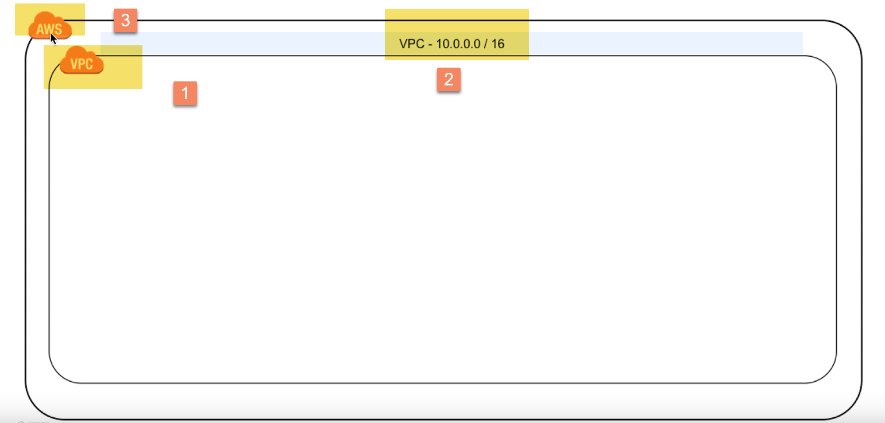

1. with a router and an Internet gateway as well as having couple of elastic IP… so that we can associate those with **NAT** gateway and also with our webserver which are within our **public** subnet …. for which we are using this default CIDR block scheme.

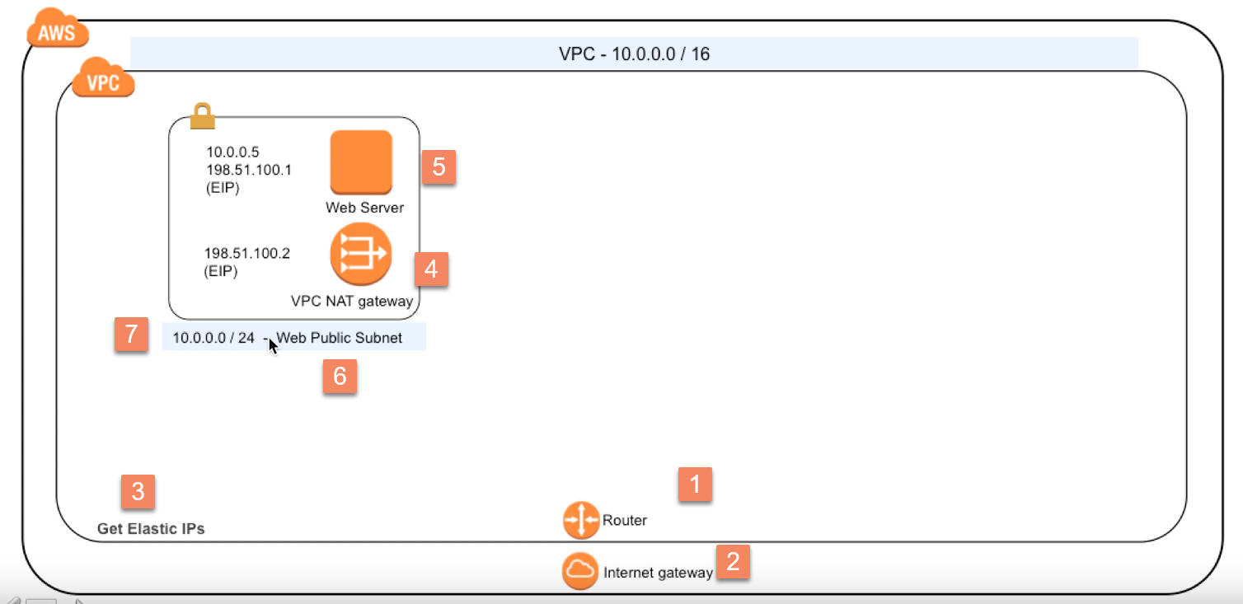

3.) Next, we are going to visualize having a private subnet… to house our app server right that this CIDR block and this app server is having this private subnet with no external IP associated because as you know app server shouldn't be talking to Internet directly. 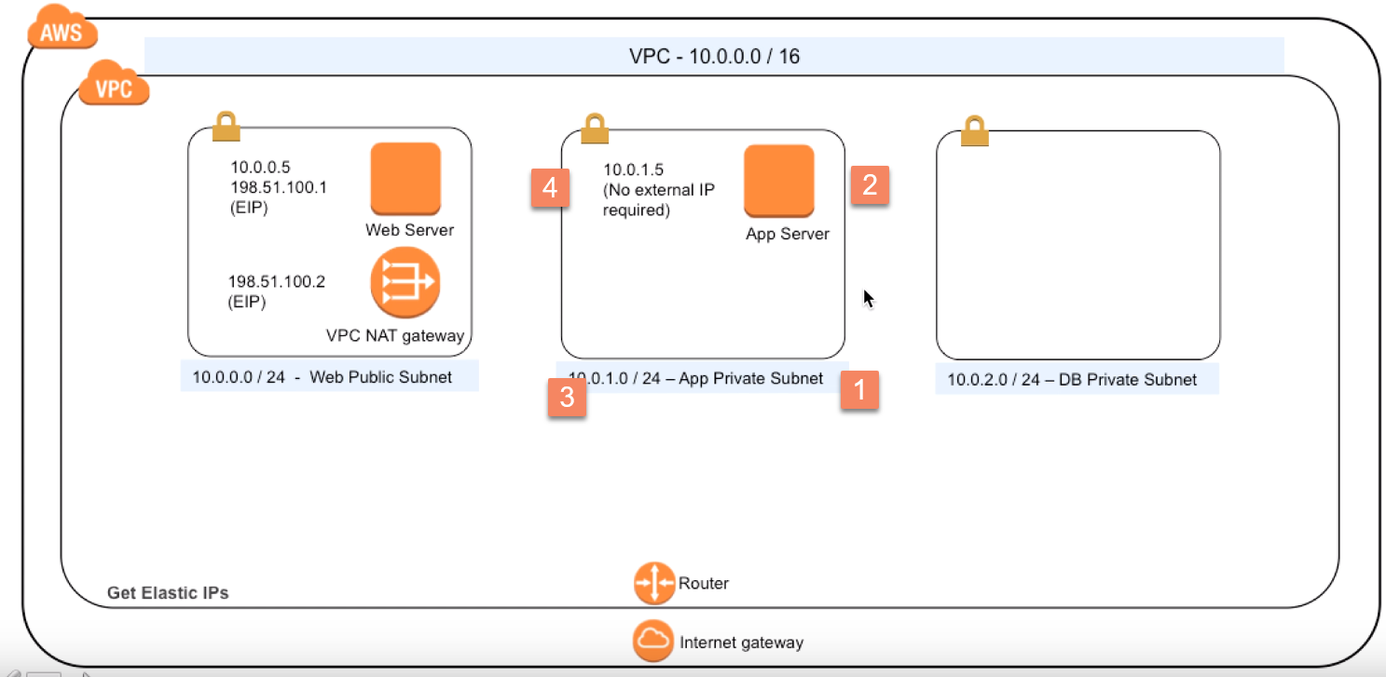

4.)Next we are visualizing having yet another private subnet with this CIDR scheme and this is going to house our database instance or database service with this private address. 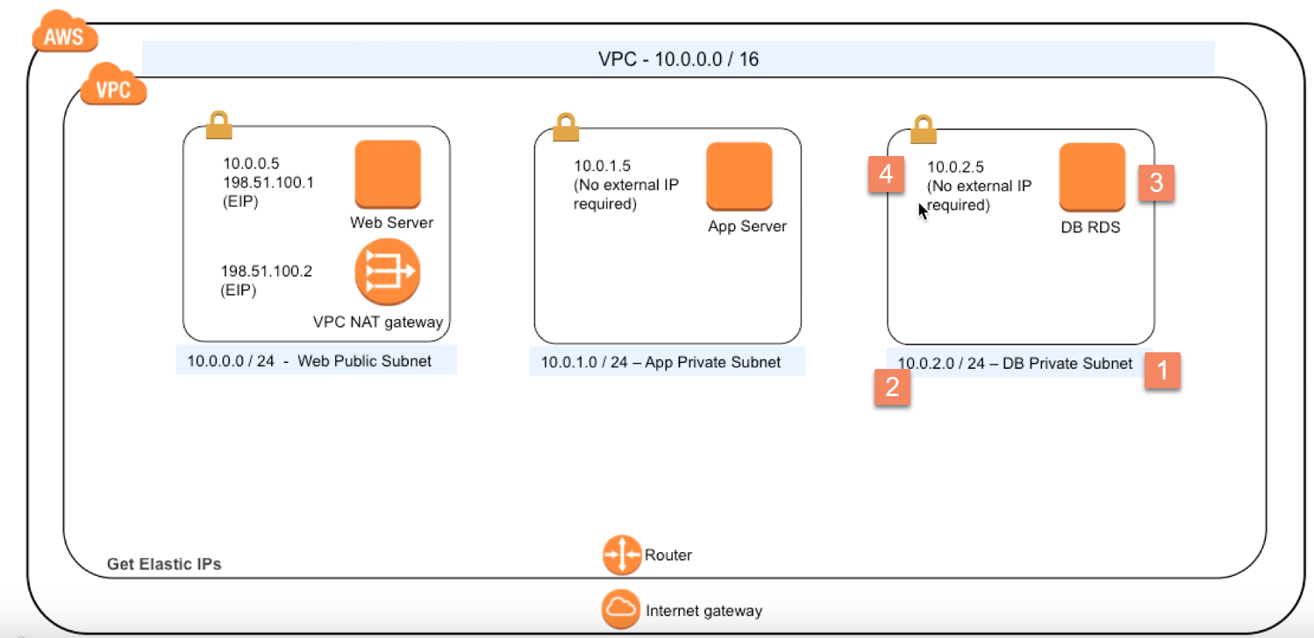

5.) next we should depict our custom route table…Here I'm showing two simple rules.

i.) the first one is allowing instances within this VPC to talk to each other.

ii.) the second rule is limiting any subnet traffic going to the Internet via the Internet gateway right because this happens to be our public subnet.

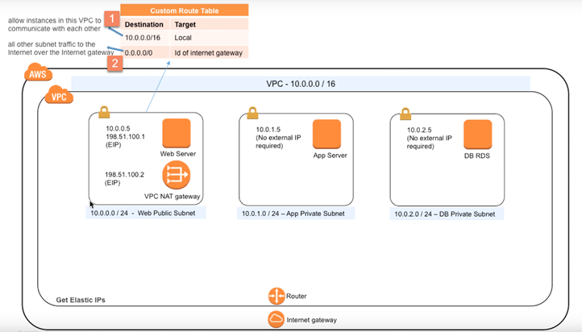

6.)the next route table has again two simple rules..

i.) the first one is similar to this

ii.)but the second rule is forcing the rest subnet traffic to go through NAT gateway service right.. because this route table is going to be associated with our private subnets. 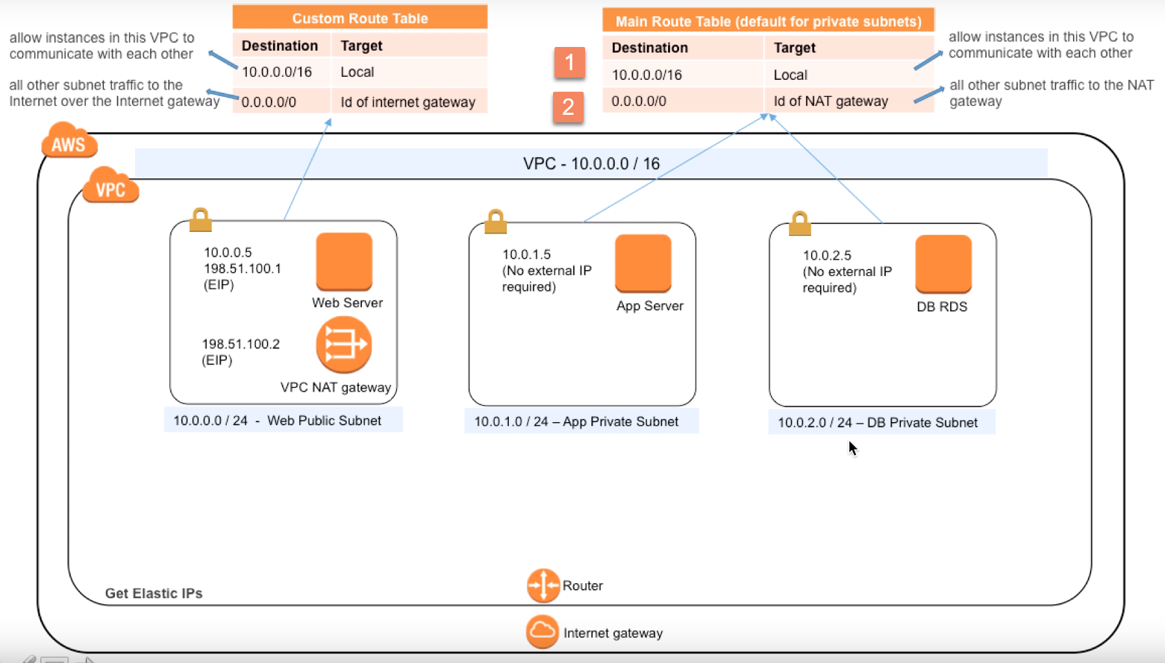

7.) Next, we need to jot down all of our security groups and the associated inbound and outbound traffic routes and finally associate or link this security group with our web server right.

Here I'm opening these inbound traffic rules these 2 outbound traffic rules and third one is very specific… so that web server and app server can talk to each other. 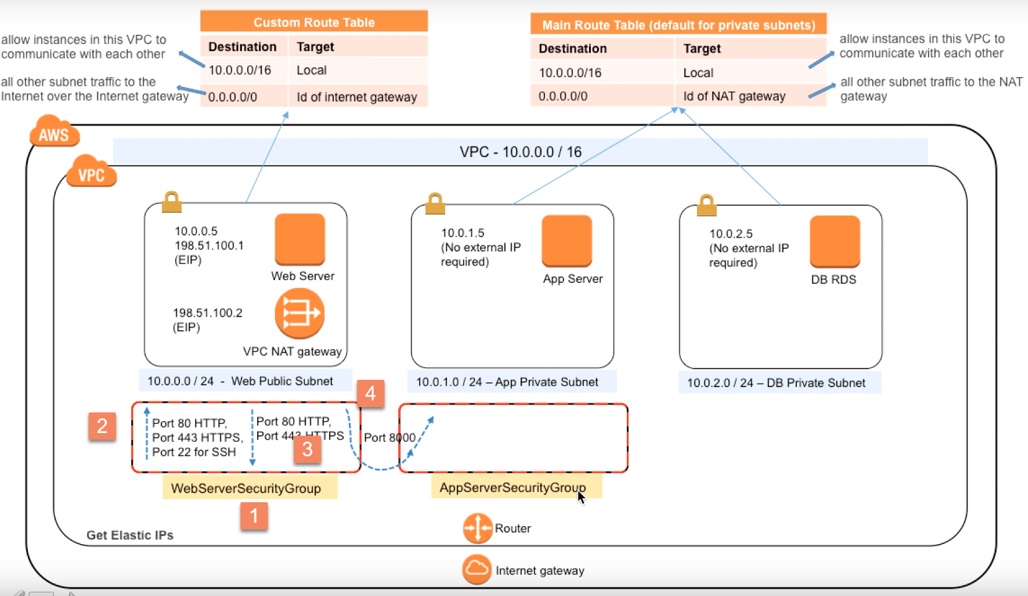

8.) this security group which is going to be associated with our app server …

* we'll have an inbound rule again on port 8000 plus
* we are going to allow some outbound traffic so that we can update our app server say with the latest binaries and patches
* we are also opening this outbound port on this security group assuming that we are using MYSQL as our database servers….

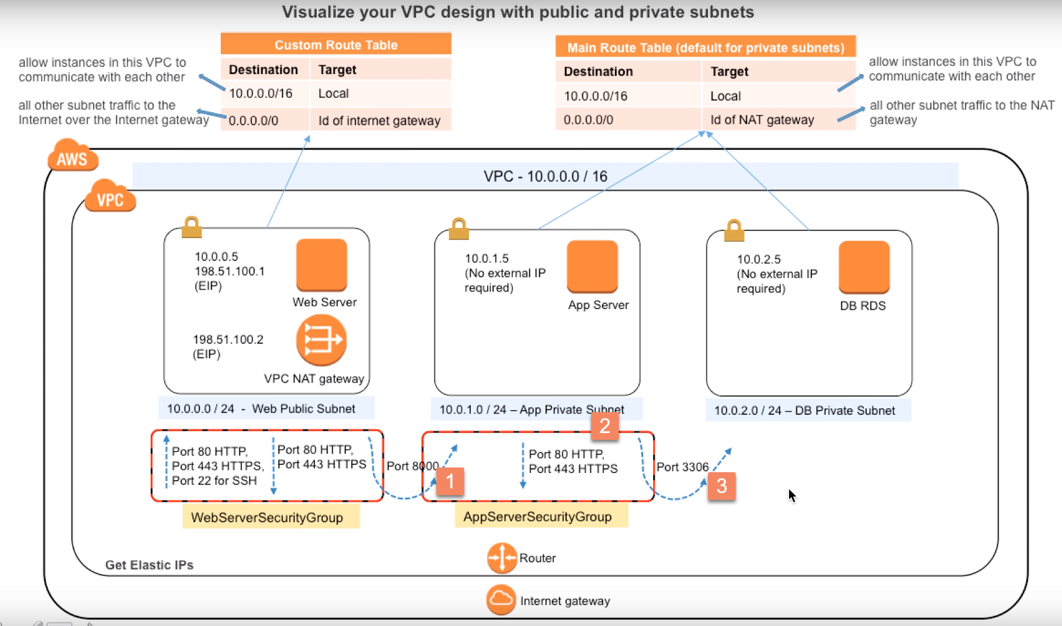

9.)for this security group again

we are opening this(3306) as our inbound traffic rule and I think that completes the entire visualization exercise.

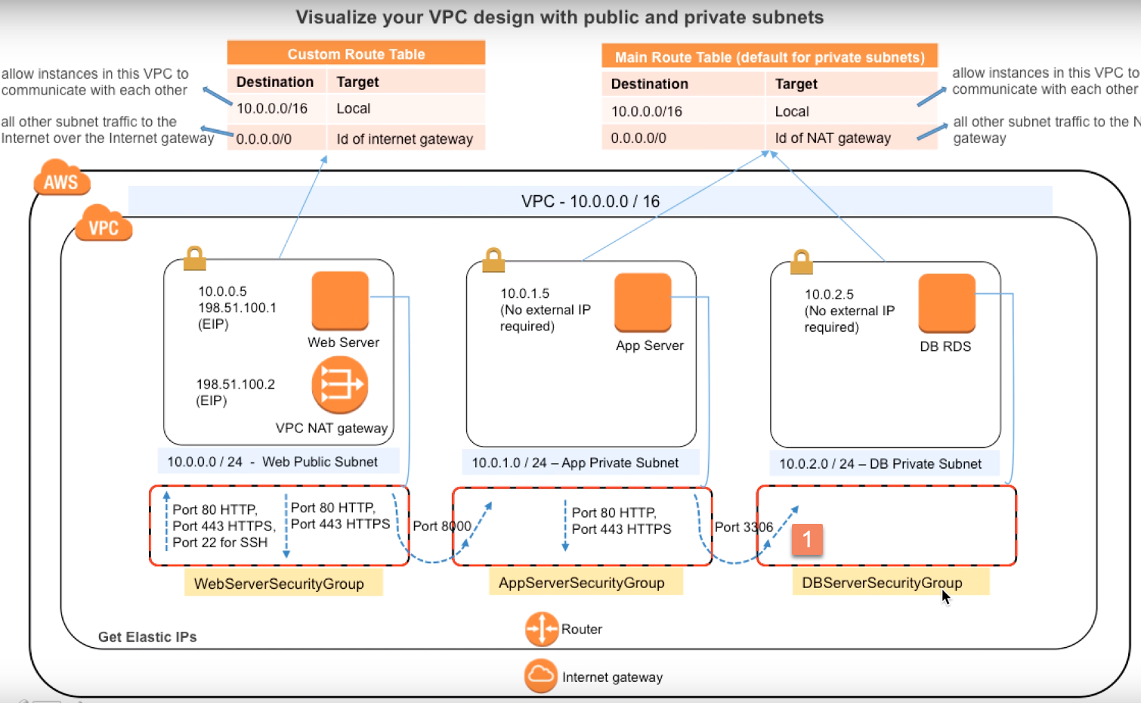

It's a good practice to elaborate these rules further with appropriate comment comments as an example here

-🡪for this security group I'm talking about all of our inbound rules did appropriate comments and as an example **port 22 which allows SSH access should have a proper source written down** so if you are opening these ports or rather allowing traffic to come from your office or home office I think we need to jot that down in a in the CIDR block format….

for outbound rules for port 8000 number the destination is the ID of our app server security group. 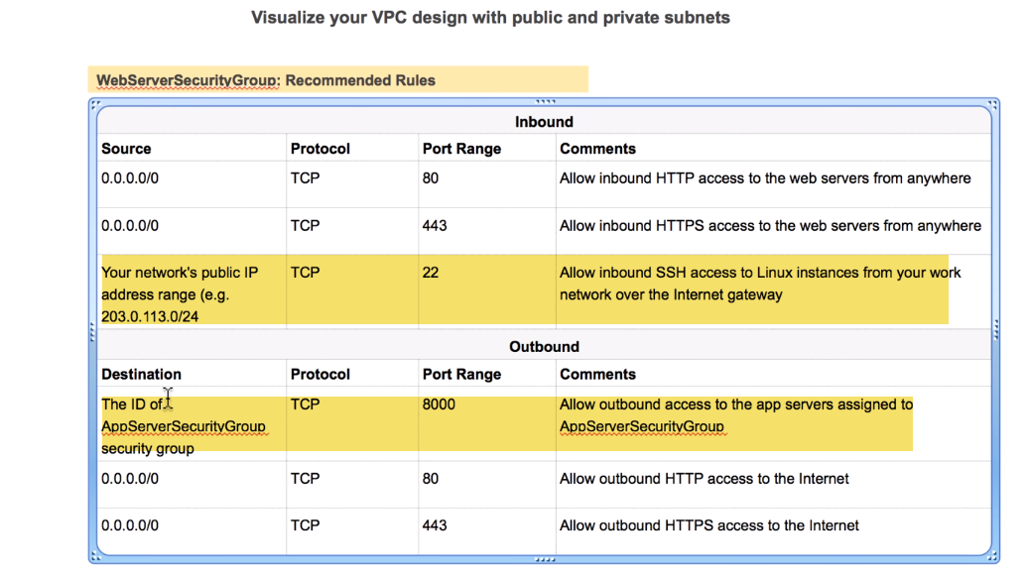

Similarly if it go to our app server security group right the source has to be the ID of our web server security group right and that's how port 8000 allows a two-way communication between web server and our app server… right so I just wanted to point that out ….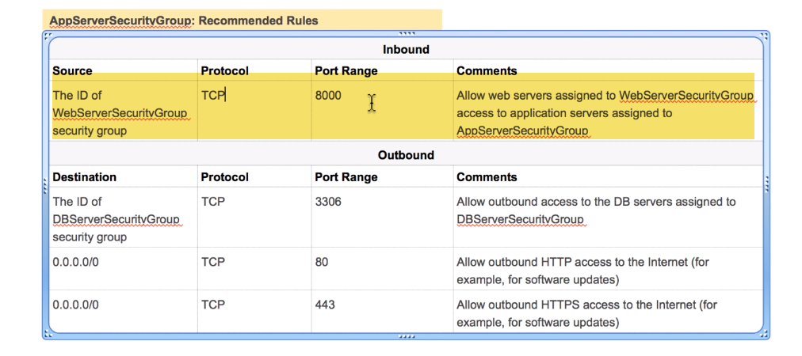

-----------------------------------------------------------------------------------------------------------------------------------------------

Once that's done again like I said translating this information over to this console is I think pretty straightforward… so let's do that well before there we need to block couple of elastic IP addresses...

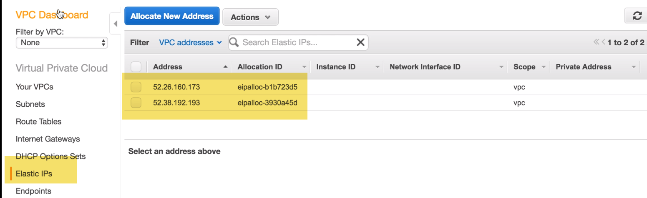

--🡪let's go to VPC dashboard and click on this wizard..

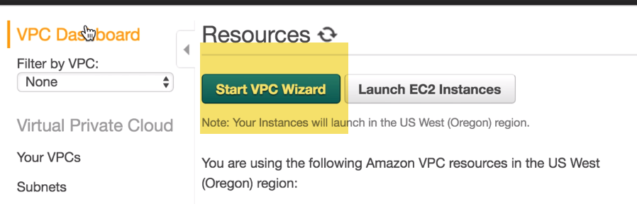

2.) select option number two….. because in our exercise we are having one public and two private subnet so I think this is our best bet …

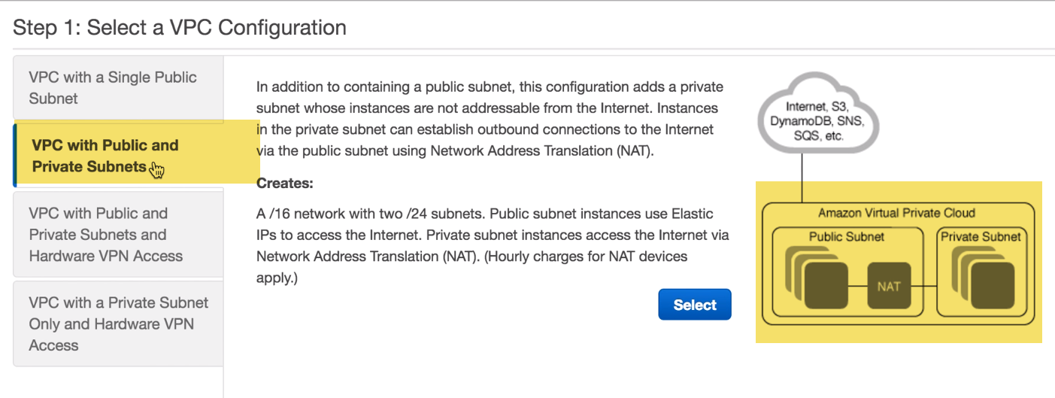

3.) I'm leaving the rest of these values to their defaults and make sure this is matching with our design and for NAT gateway associate one of the elastic IPS .. and here we can create our VPC now..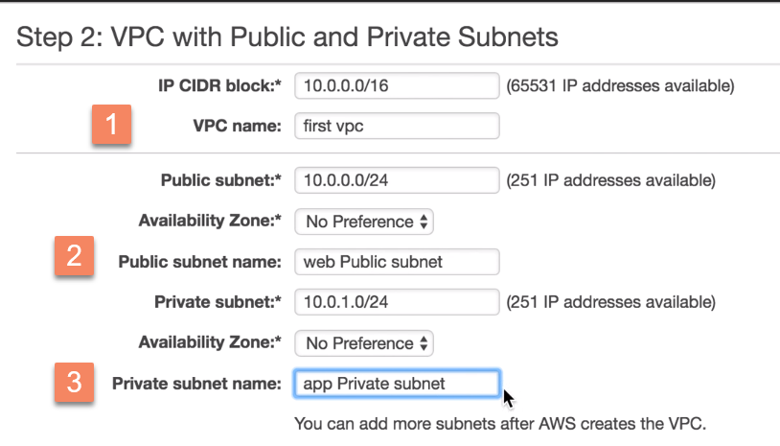 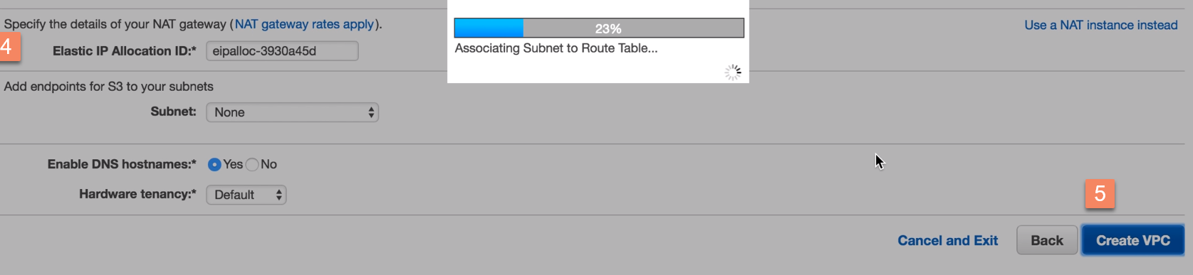

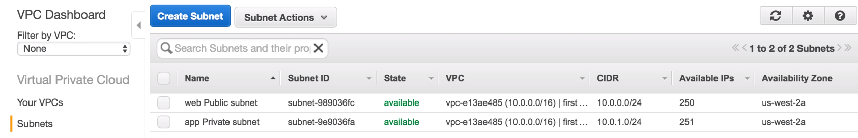

1. **let's create actually our third subnet r**ight we are supposed to have three subnets and I think we already have to create it as part of our VPC wizard exercise we just need to create third one but before going there we need to make sure cidr blocks are matching with our script 0 0 1 0 0 0 1 0 and third one has to be 2.0



so let's just quickly create DB private subnet correct VDC and with CIDR block and this will allow us to have 251 IP odd addresses .

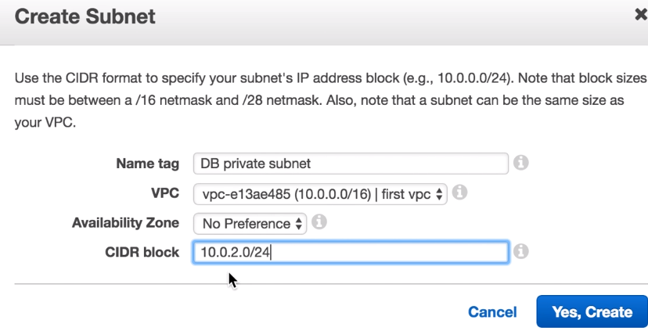

1. Next we need to figure our route tables and hopefully we should have 2 route tables already present right this one is main so this must be custom… 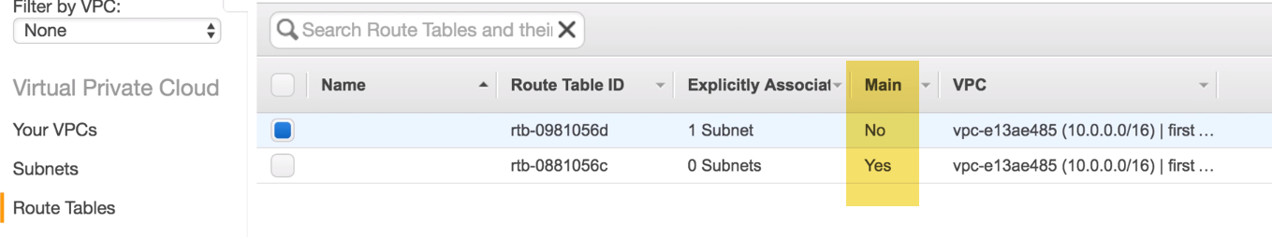
2. Tag it.
3. Routes entries

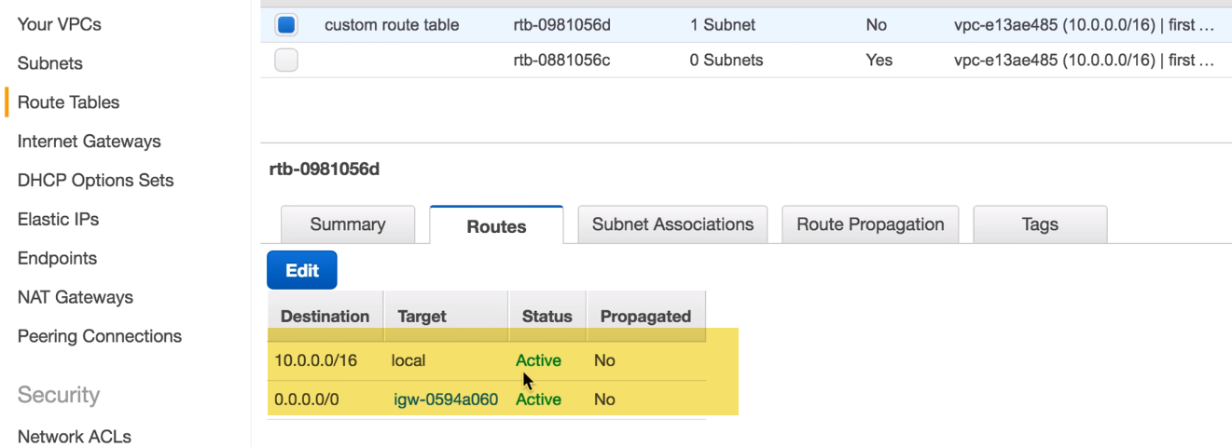

This matches with intended rule set… 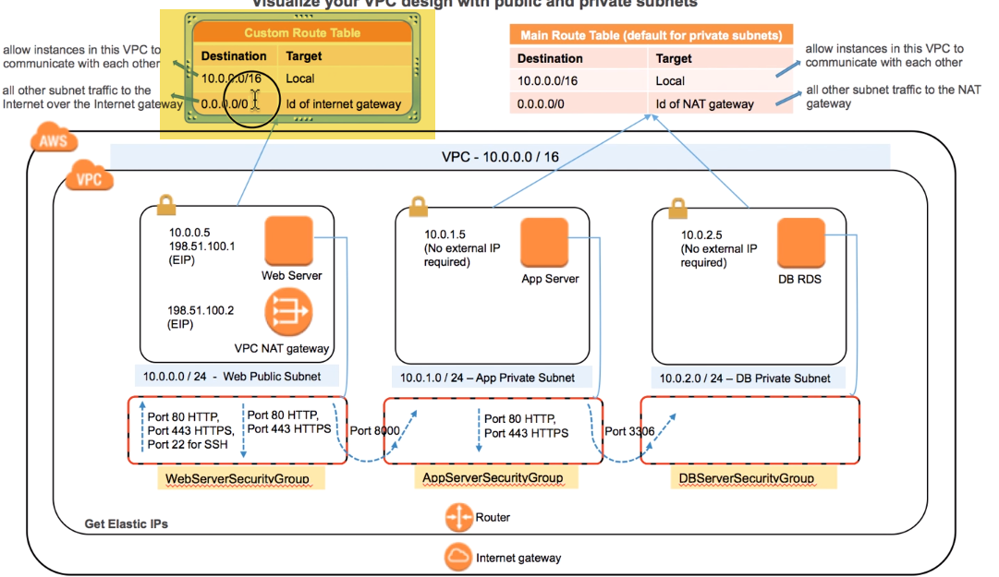

1. Subnet associations: make sure that this main route table is associated with public subnets ..

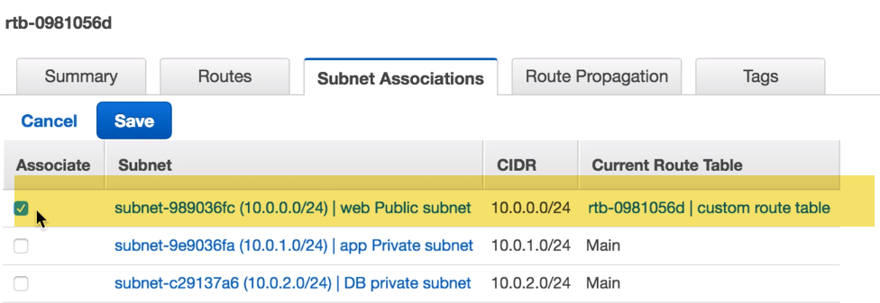

1. On Default route Table:
2. Tag
3. Routes:

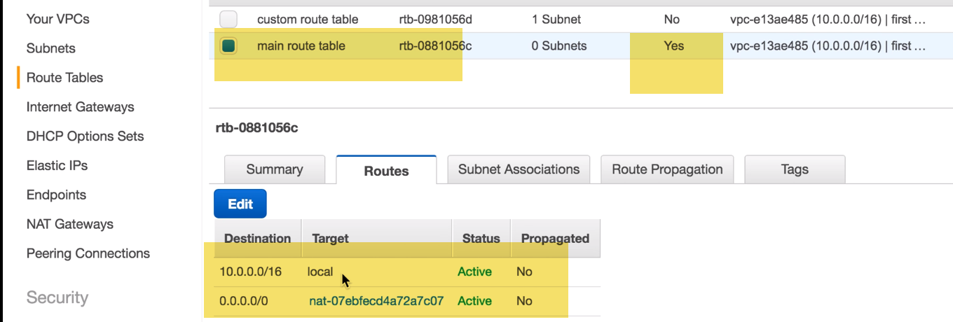

1. Subnet associations:

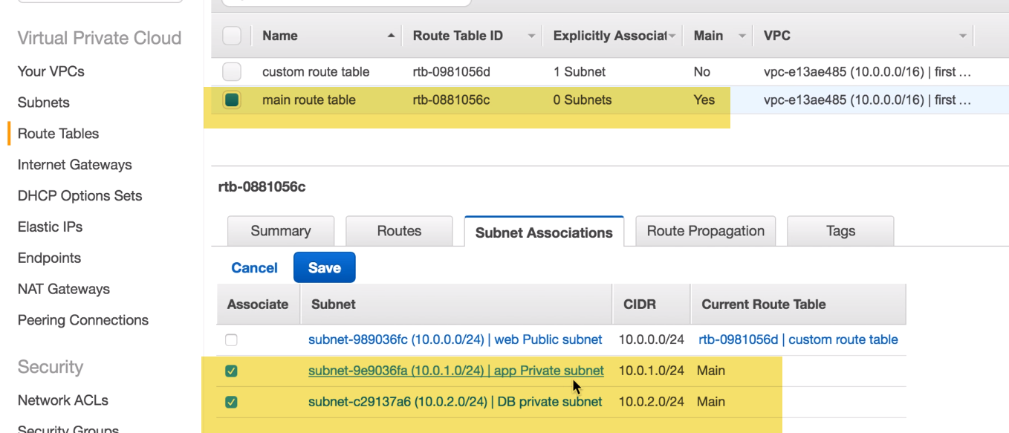

1. **security groups**

a.)first security group is called web server security group with these 2 inbound and these 3 outbound rules

**For SSH** access: source should be very limited to either our home office or work CIDR range …

and limit access from there

**port 80/443** :web server can expect traffic to come from anywhere. on both of these ports.

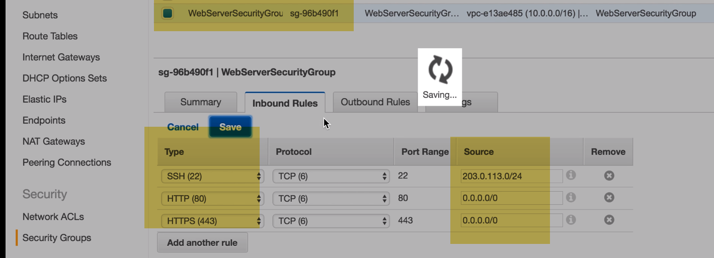

**outbound** has to allow traffic going to the ID of APP server security group and these 2 regular outbound ports.

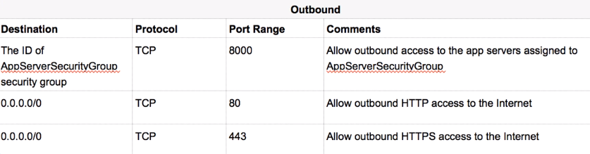

creating a custom rule on port 8000 …

Destination should be ID for app server security group… 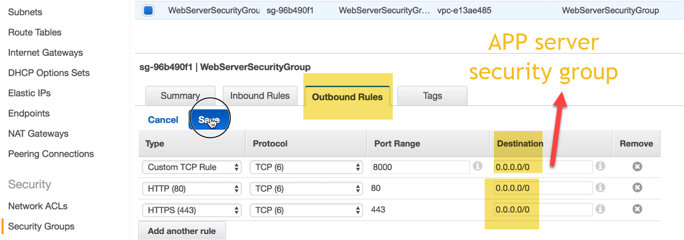

b.) let’s create our second security group: 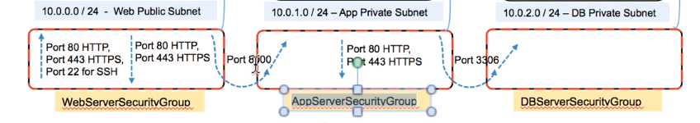

inbound traffic rules: we need to open port 8000 on inbound traffic rule so let's do that and it must be the ID of yes you're correct of our **web server security group**… 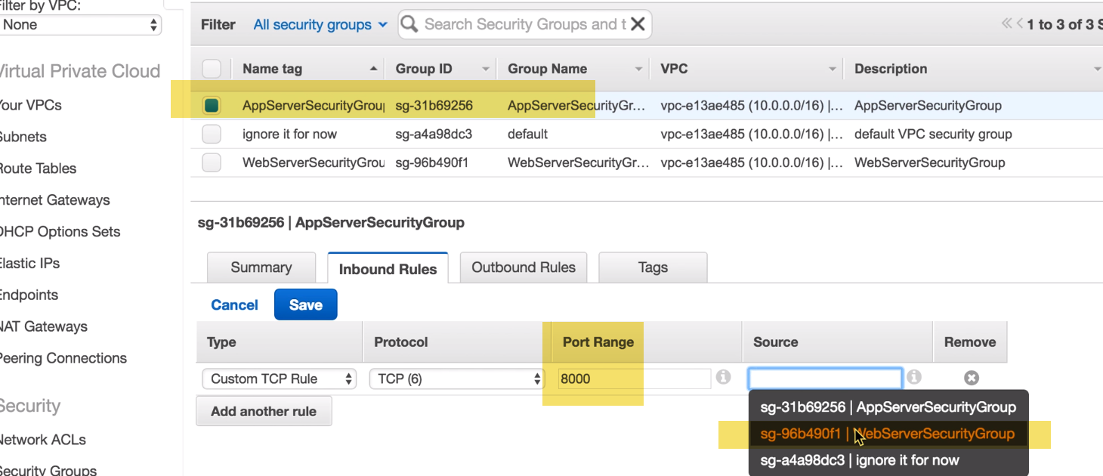

**outbound traffic** **rules** :we need to limit outgoing traffic to actually on these ports ….why we are opening these ports???? because from time to time we may need to patch our app server right and because of NAT rules this

traffic will go through our NAT server… 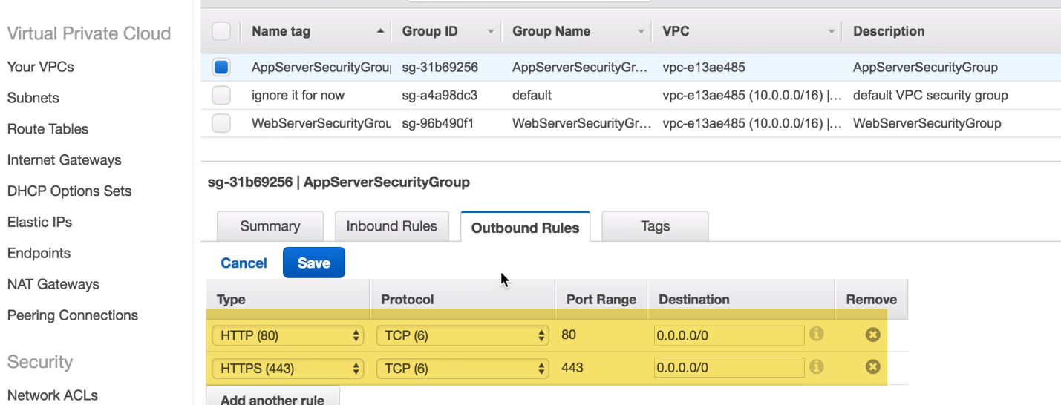

**last security group**

**inbound rule:** only 1 inbound 3306 and the source should be our APP server security group. 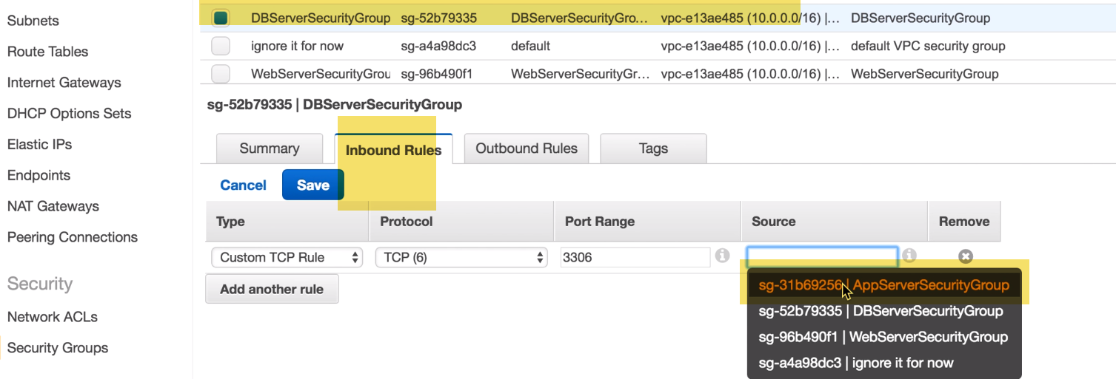

**outbound traffic:** should have a custom rule allowing APP server to DB server communication.

So,this APP server should be pointing to DB server related security group 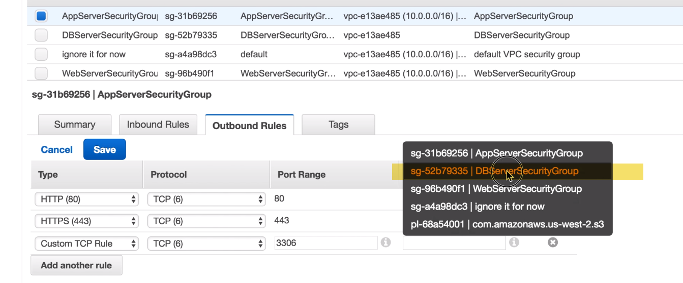

--🡪let's do the save and quickly revisit a webserver

**Inbound**: from home office 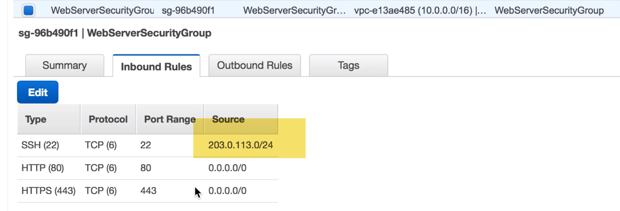

**outbound:** is limiting and this one now we need to revisit and **fix this on 8000 web server should be speaking with app server…** 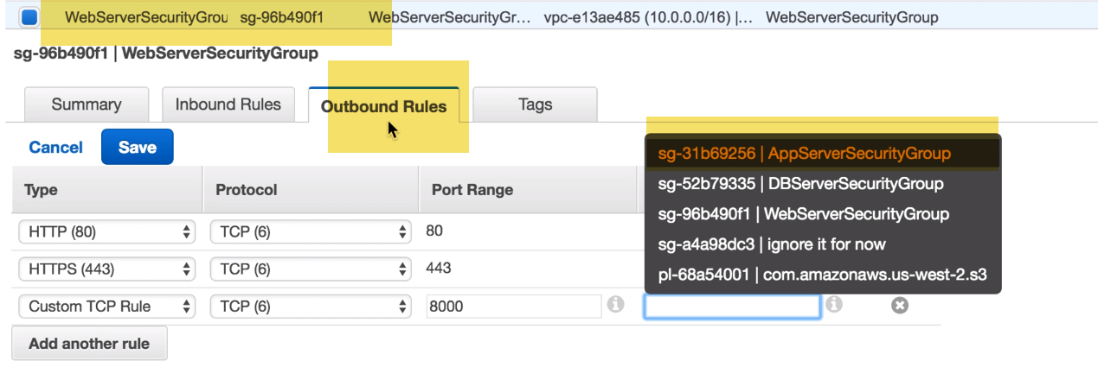

**Creating VPC:**

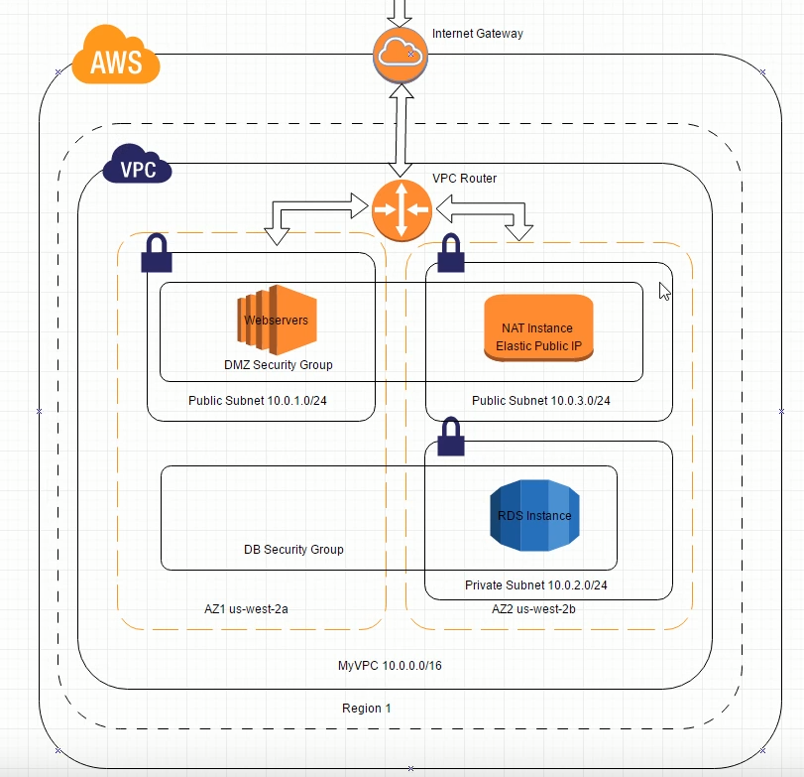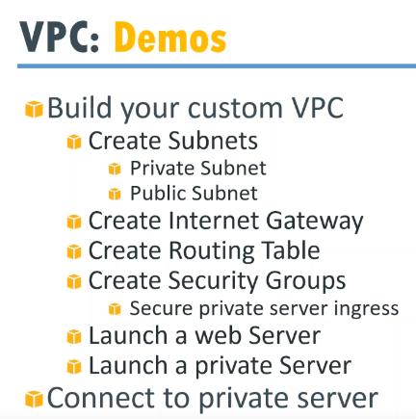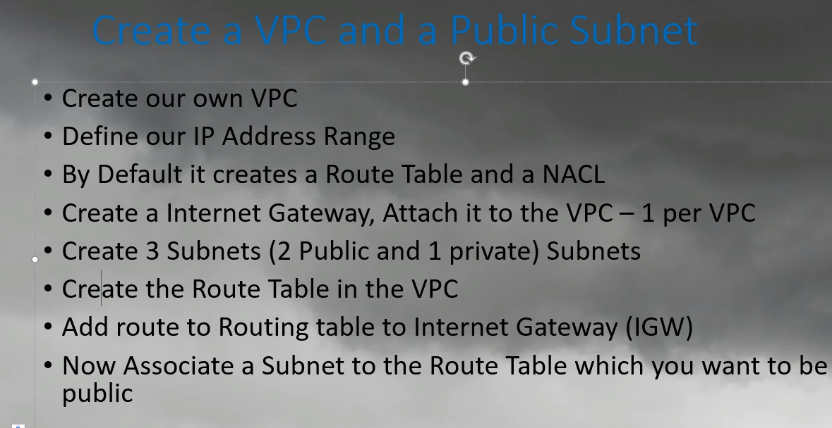

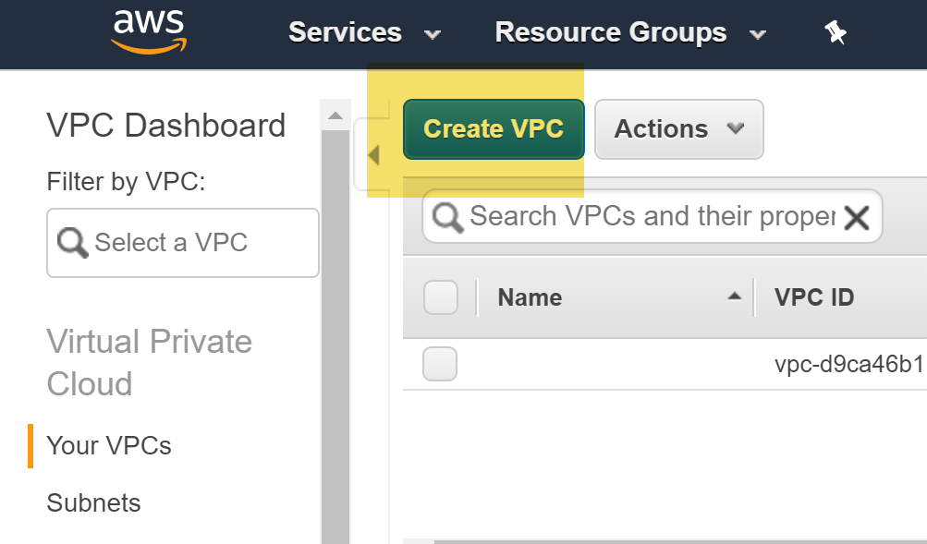 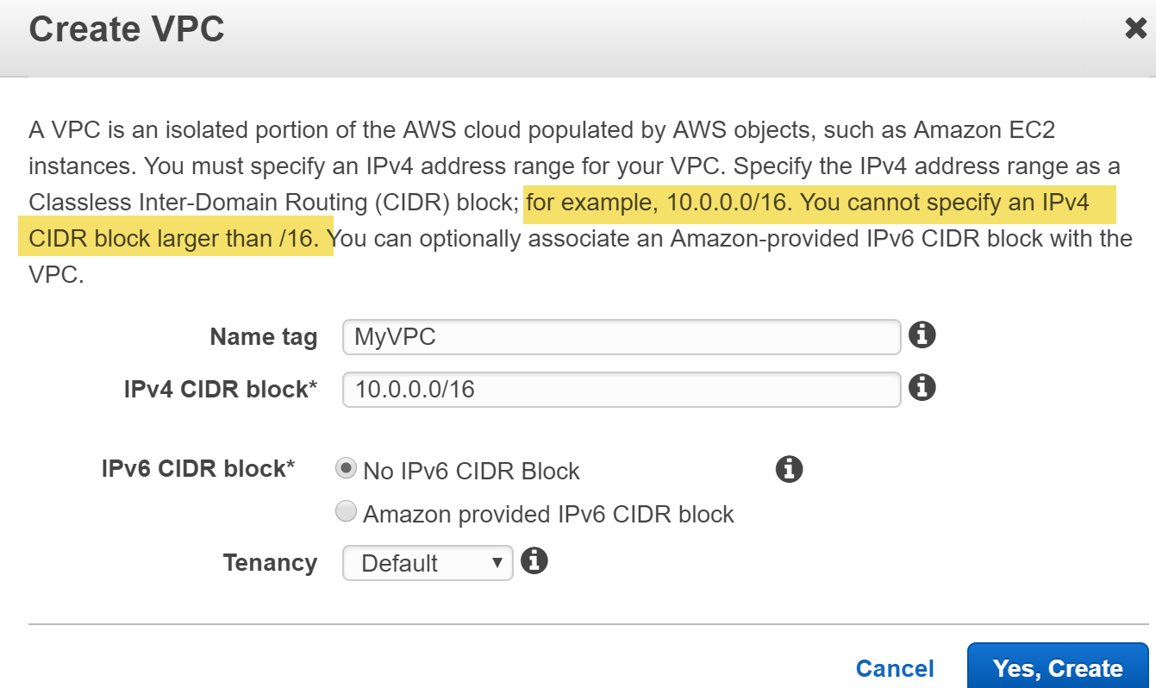 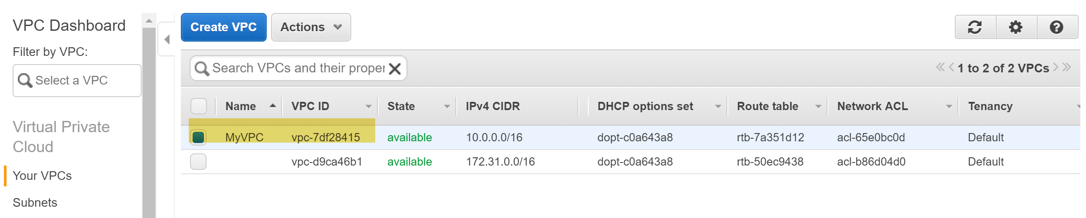

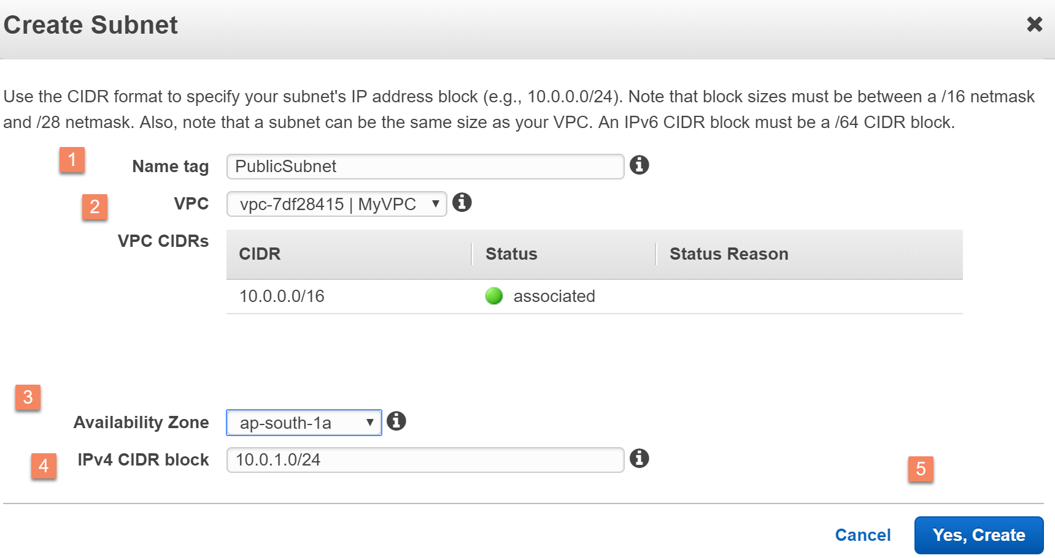 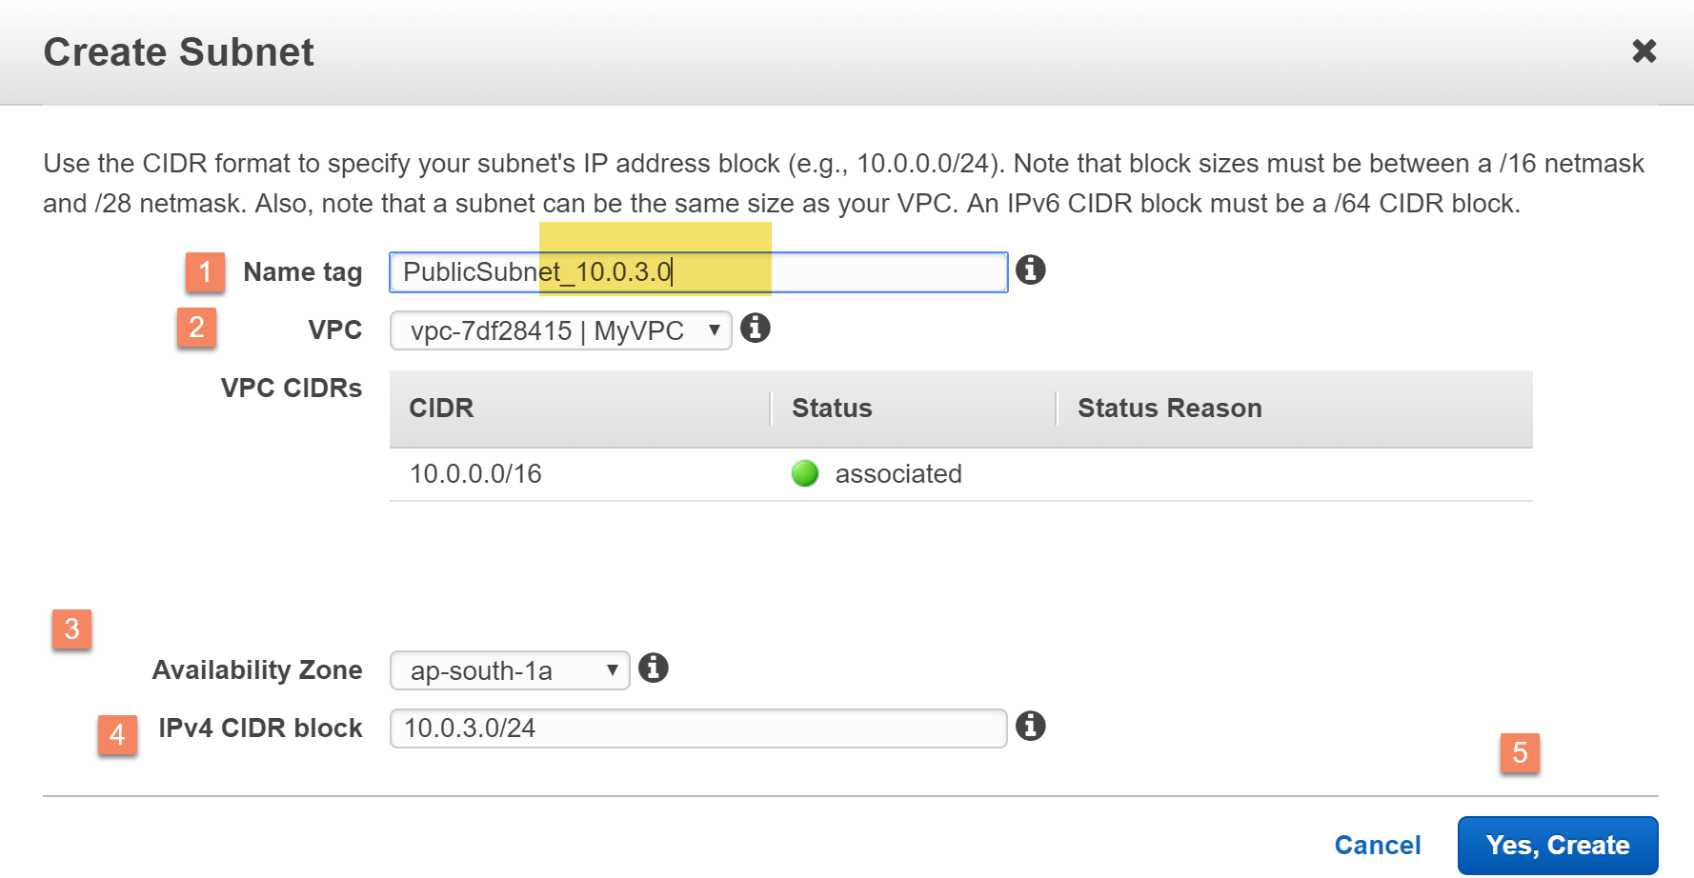

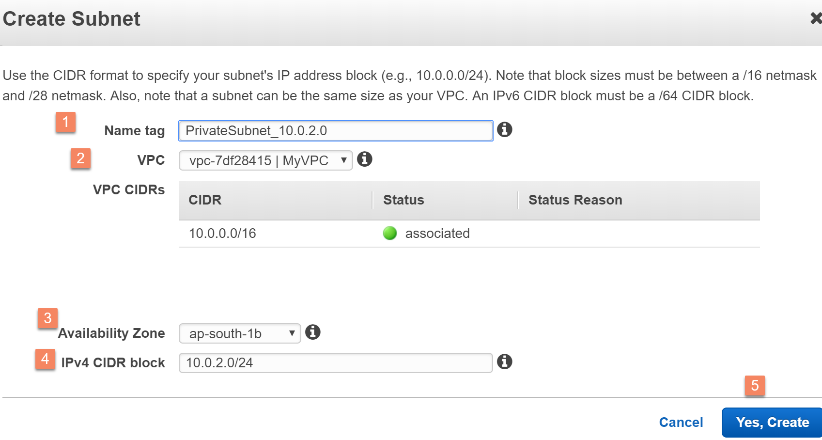 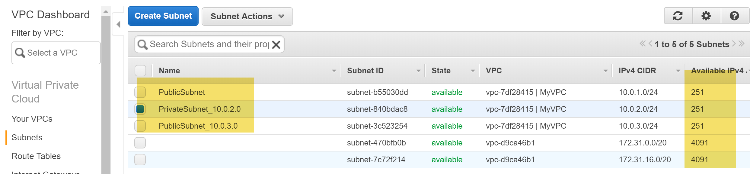

We can only create 1 IGW/VPC.

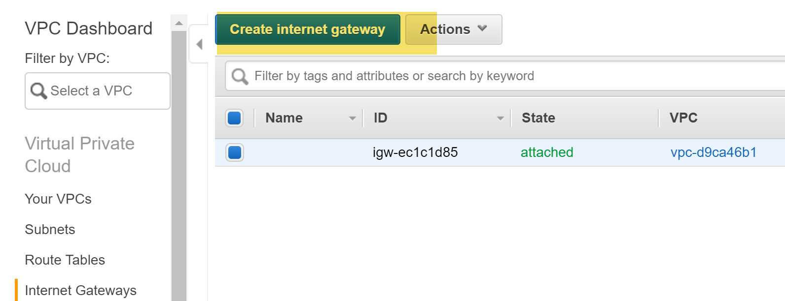 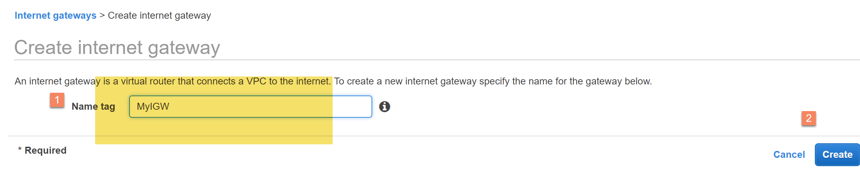 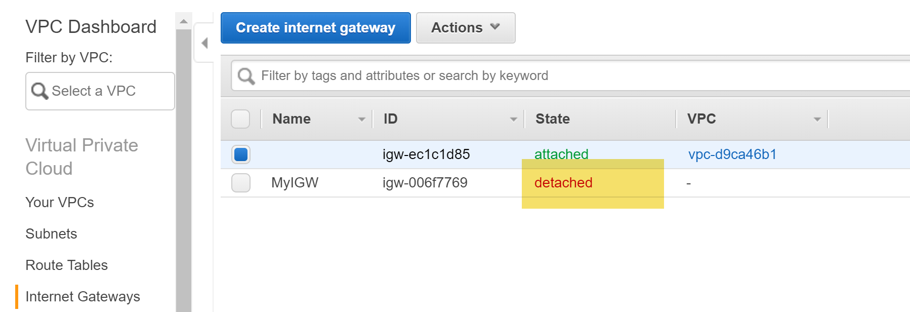 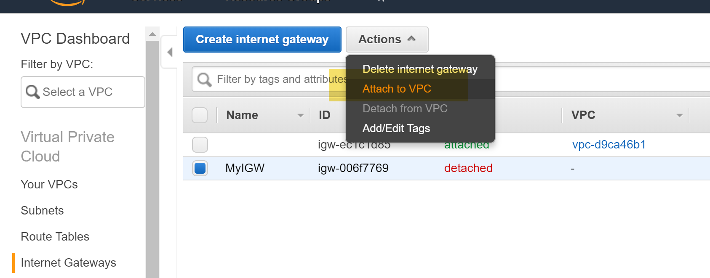

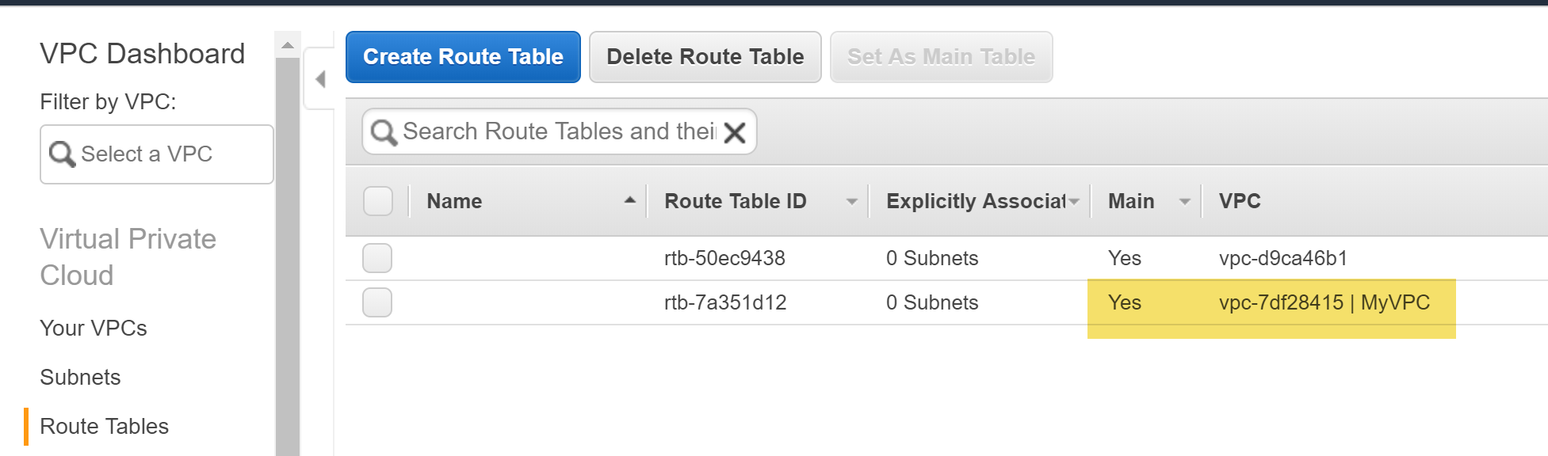

Default route table created whenever, we create VPC. 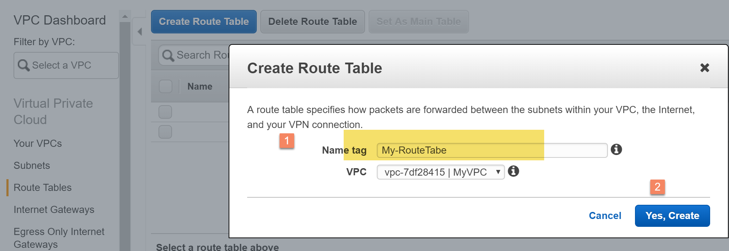 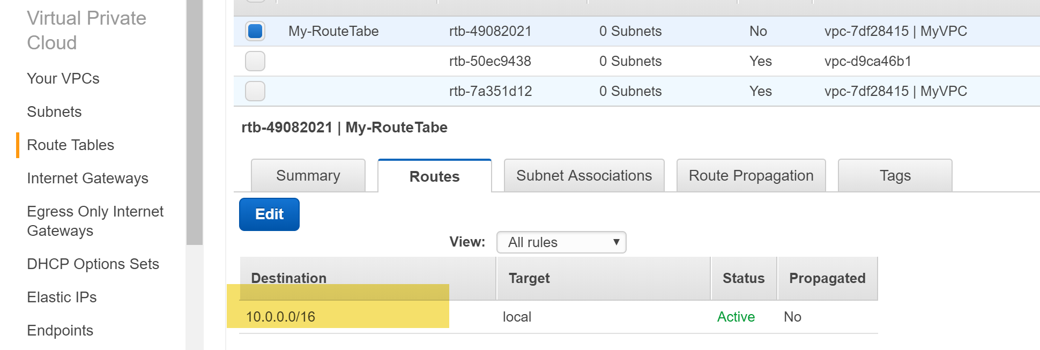 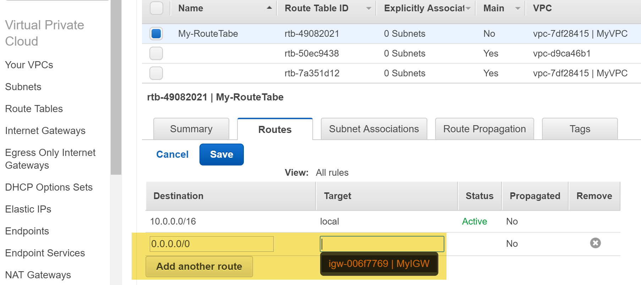 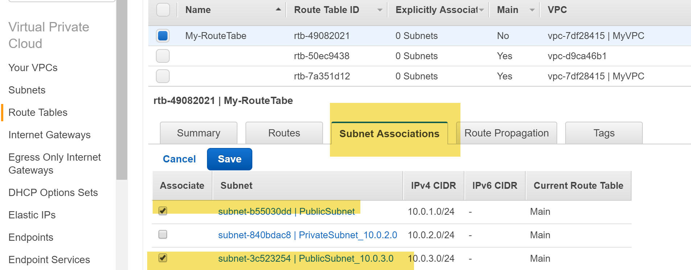 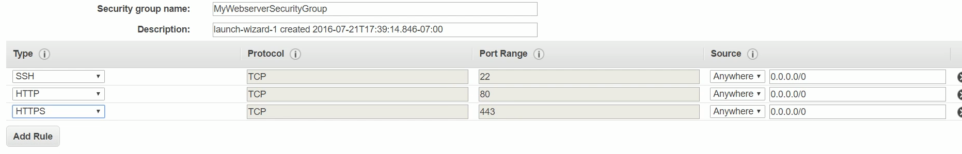 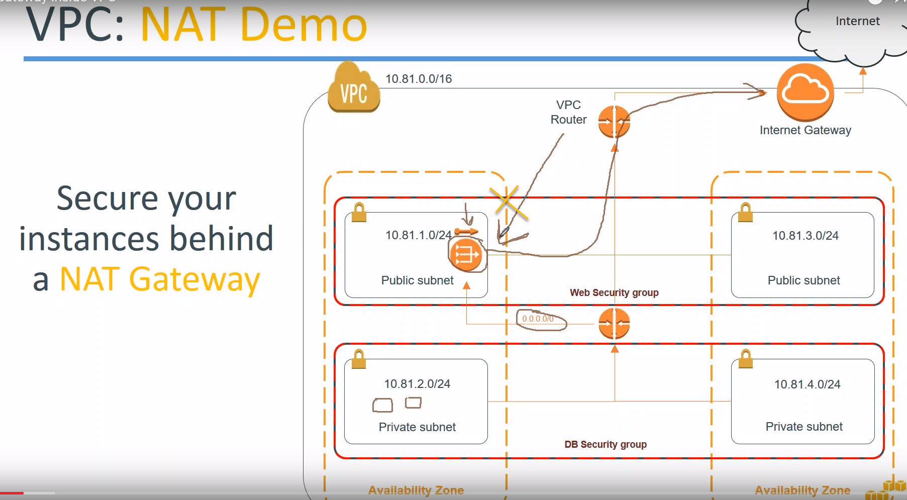 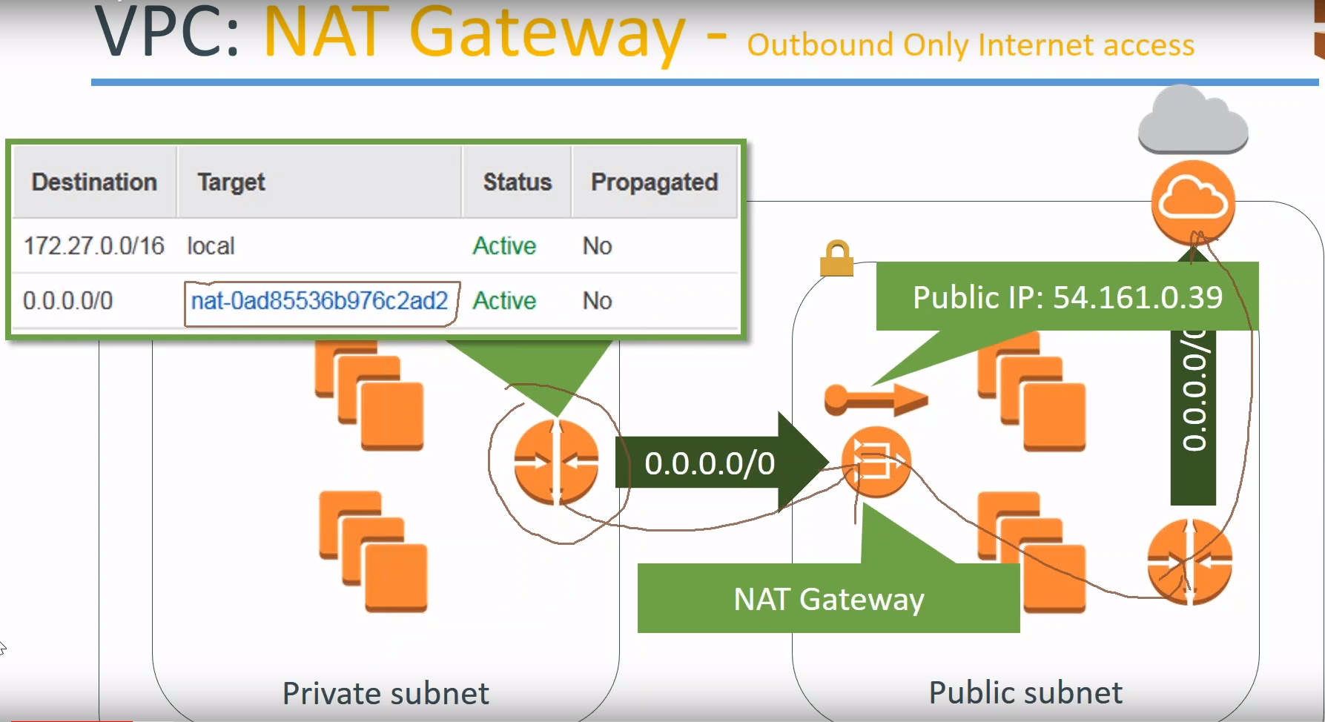

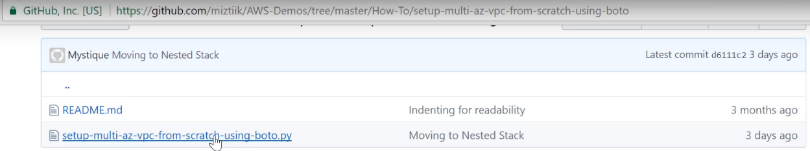

AWS VPC with Private Subnet and NAT Instance and Private Instance

Createe NAT Gateway..It needs to be under Public subnet(so it can connect to internet), with EIP.

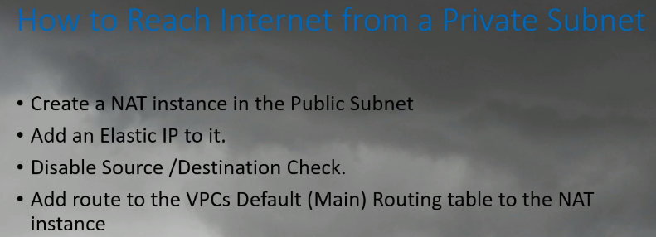 (create instnace (DB) inside my private subnet)..and havent assigned any public IP to it

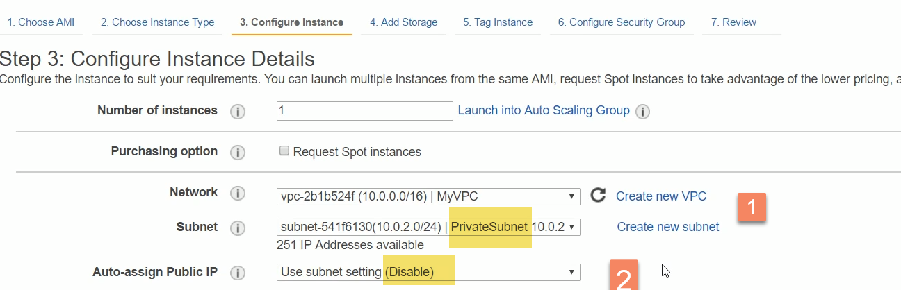

Disable: Not to allow someone to connect from outside… by giving a public Ip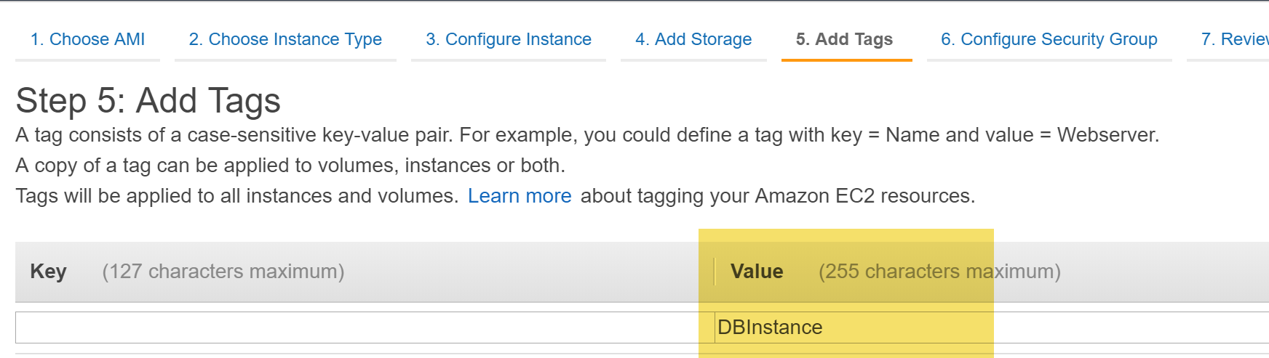 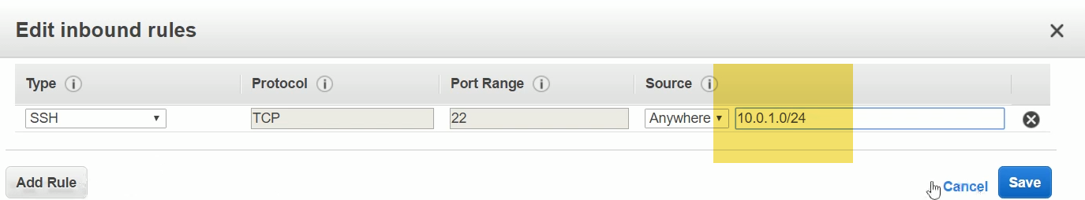

Ssh from my public subnet ..

Not able to access-🡪No public Ip + no inblund rule othert than APP server sever sec . group.

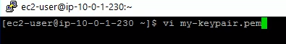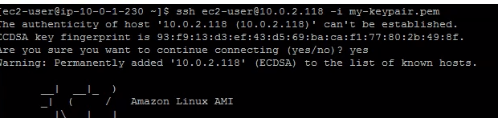

I Can login from app server to Db server…But no access to internet…

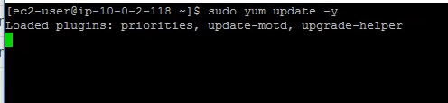

How to download packages from internet???? 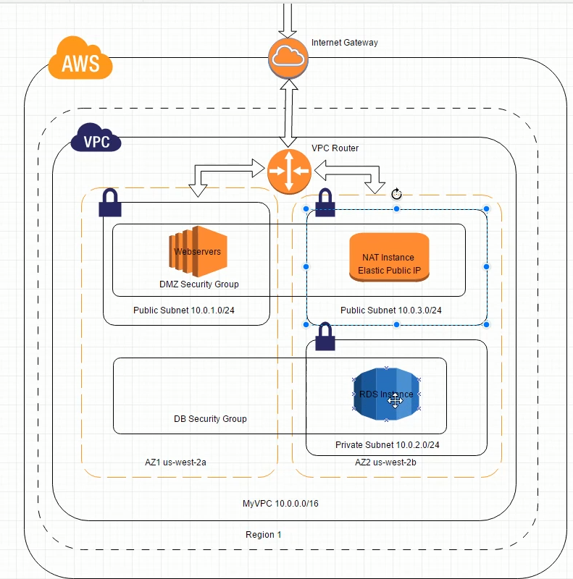

I will create NAT instance in 10.0.3.0/24.

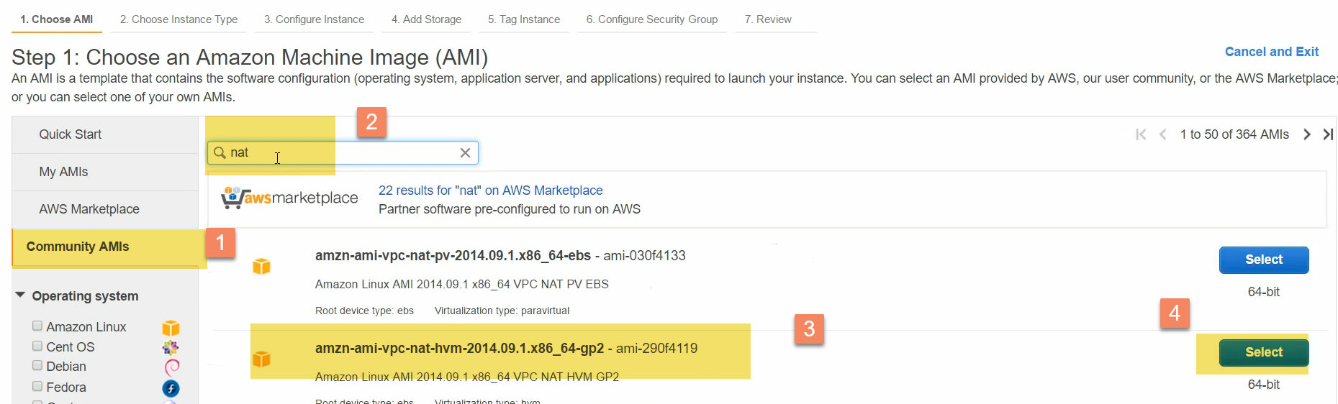

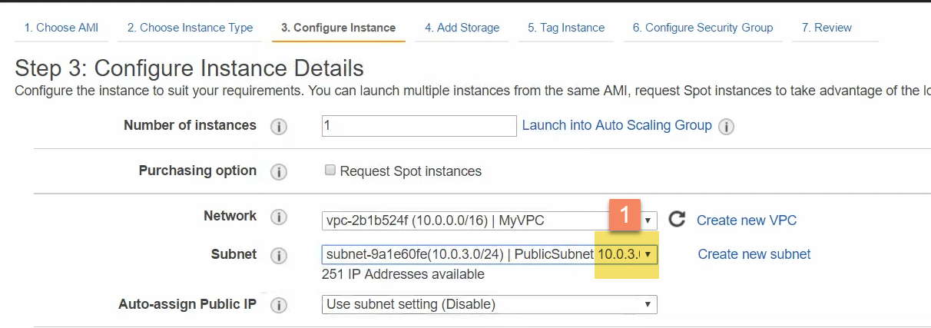

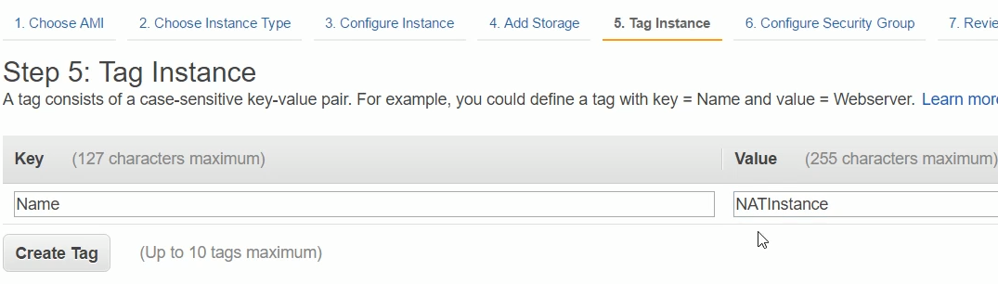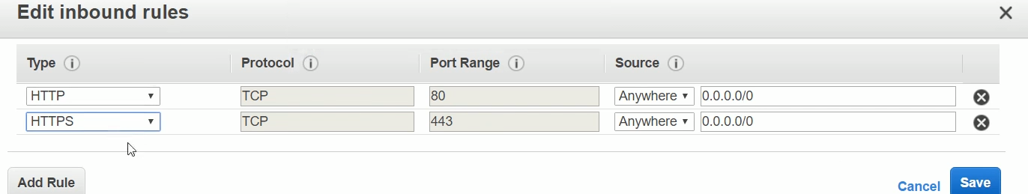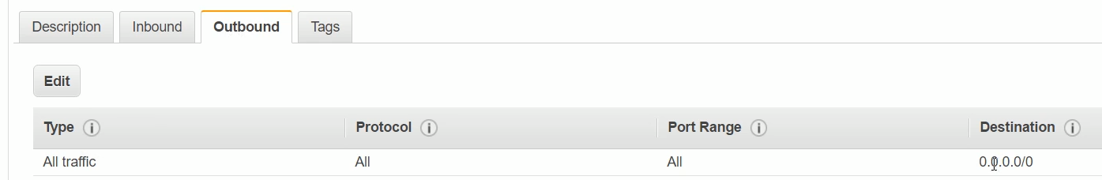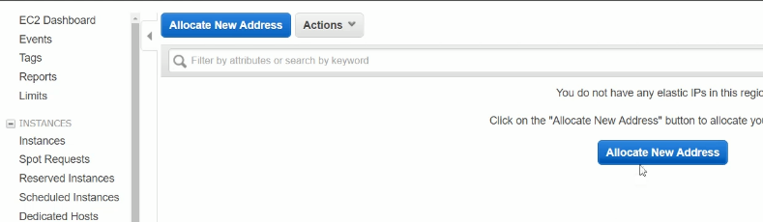 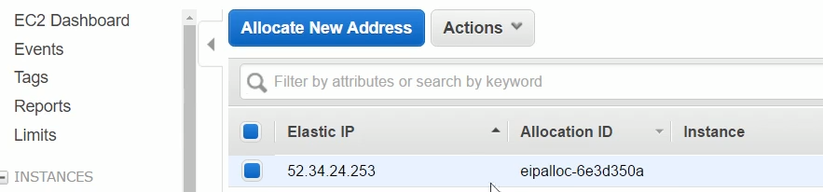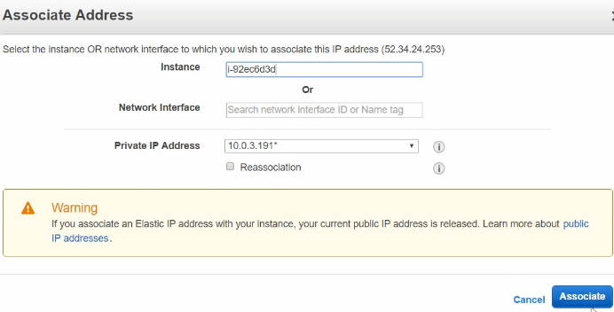

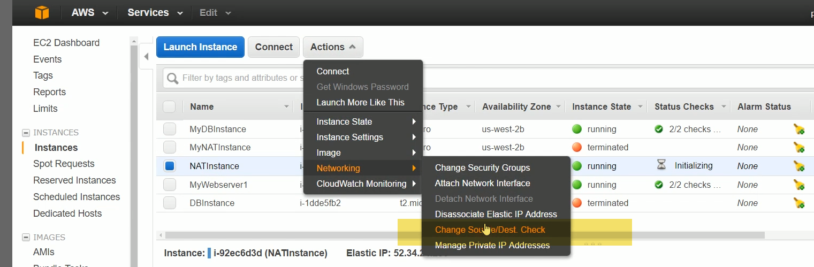

Every instance you create, will check for source and destination for all traffic.. It is enabled by default, when we create an instance..In a anat instance, we don’t want that..We have to disable.otherwise it wont work..

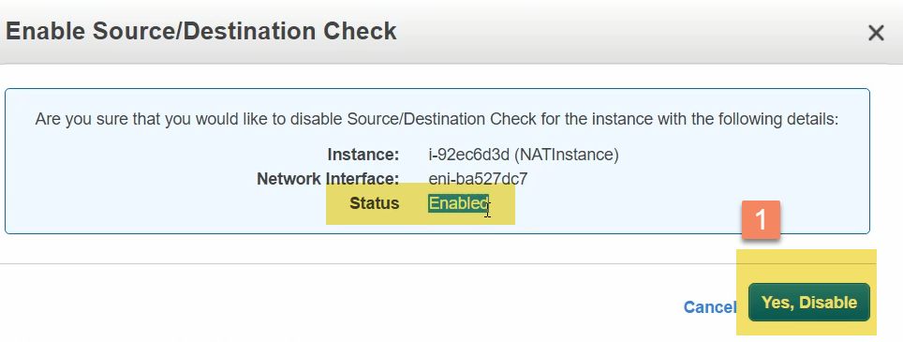

We have security group,Nat insatnce,and allocatd EIP to it..Now, we have to give RDS instance to NAT 